STEAMED RIBS WITH BLACK BEANS (豉汁蒸排骨)  COOK TIME: 20 min  SOURCE:  #comfort-food #steamed #pork | 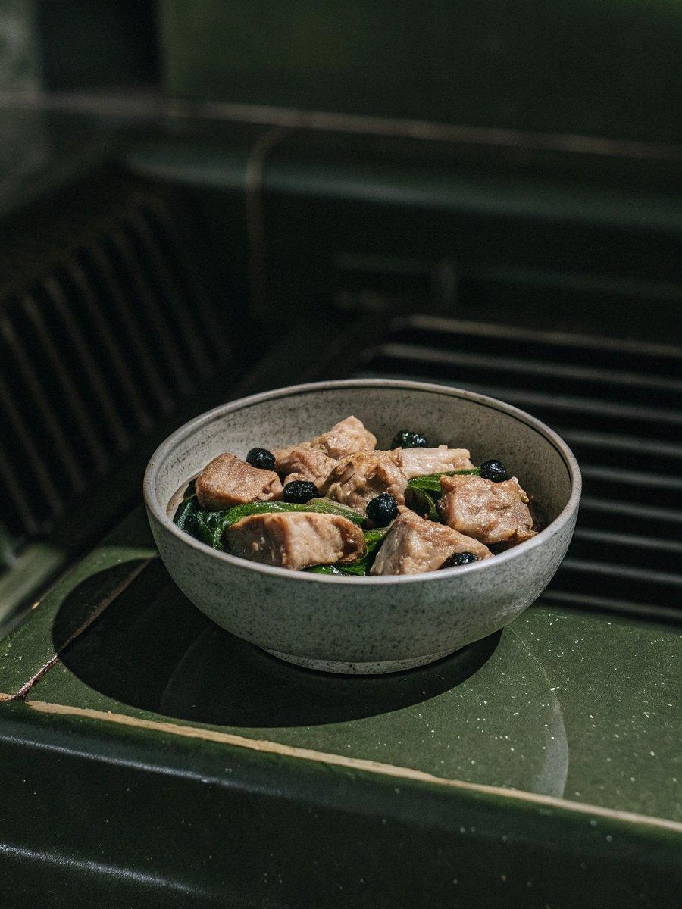

INGREDIENTS  - 1 lb pork ribs (cut into bite-sized pieces (see note 1)  - 1 tsp baking soda, (aka bicarbonate of soda)  - 2 cups (480ml) water  - 1 tbsp cornstarch  - 1/2 tsp salt  - 1 tbsp neutral cooking oil  - 1 tbsp garlic (minced)  - 1 tsp ginger (minced)  - 1 tbsp fermented black beans (rinsed and coarsely chopped (see note 2)  - Fresh chili pepper (finely chopped, to taste)  - 1/2 tbsp light soy sauce  - 1/2 tbsp oyster sauce  - 1/2 tbsp Shaoxing rice wine  - 1/4 tsp ground white pepper  - 1/4 tsp sugar  - Scallions (finely chopped) | PREP  COOK  1. Tenderize the ribs  2. Put ribs into a large bowl. Add baking soda and water. Mix to dissolve. Then leave to soak for 30 minutes, or up to 2 hours.  3. Discard the soaking water, Rinse and rub to clean the ribs under running water. Drain and use kitchen paper to dry the ribs as much as possible.  4. Add salt and cornstarch to the ribs. Rub with hands to ensure a thorough coating.  5. Marinate the ribs  6. Heat oil in a wok/pan. Fry garlic, ginger, and fermented black beans over low heat until fragrant (do not burn the aromatics). Add fresh chili, light soy sauce, oyster sauce, Shaoxing rice wine, white pepper and sugar. Simmer for 10 seconds or so, then remove from the heat.  7. Once the seasoning sauce cools down, pour it over the ribs. Mix well to coat evenly. Leave to marinate for at least 30 minutes, or overnight in the fridge (see note 3).  8. Steamed the ribs  9. Transfer the ribs to a plate for steaming. Arrange them in a single layer without overlapping.  1  0. Bring water to a full boil in a wok/pot which you use for steaming (see note 4). Then put the plate of ribs over a steamer rack, or inside a steamer basket. Cover with a lid and leave to steam over medium-high heat for 20 minutes.  1  1. Garnish with scallions and serve the dish immediately with steamed rice, alone or with other savory dishes.  PLATING

