GULAI TUMIS (TAMARIND FISH CURRY)  COOK TIME: 40 min  SOURCE:  #spicy #comfort-food #curry | 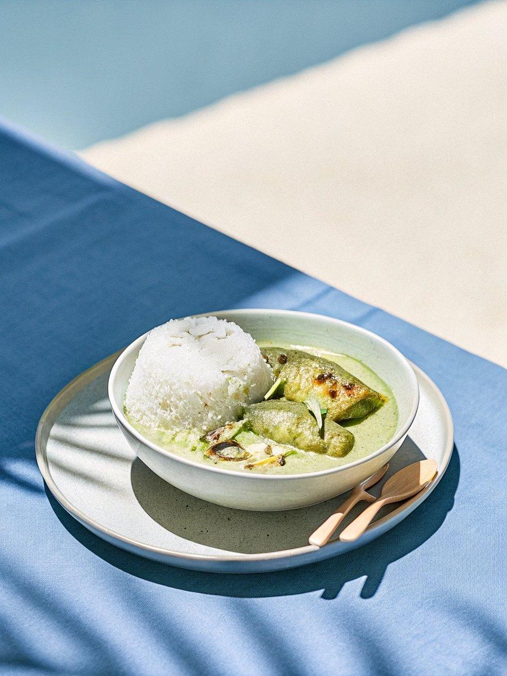

INGREDIENTS  - 160 g shallots  - 6 g candlenuts  - 12 g galangal (lengkuas)  - 6 g peeled garlic  - 3 stalks lemongrass (sliced)  - 8 g fresh tumeric (or 2 tsp tumeric powder)  - 90 g dried chillies (20-25 (soaked in hot water for 15 minutes and drained))  - 16 g Asian shrimp paste (belacan)  - 1/2 cup oil  - 3 tbsp tamarind pulp  - 600ml (2.5 cups) water  - salt (to taste)  - sugar (to taste, optional)  - 1 bud ginger flower (finely chopped)  - 800 g stingray ( sliced)  - 8-10 ladies fingers (steamed) | PREP  COOK  1. Heat oil over low heat and sautÃ© the ground spice paste until the oil separates from the paste and it becomes fragrant (about 15 minutes).  2. Mix the tamarind pulp with water and strain to extract the tamarind juice. Add the juice to the spice paste and bring to a boil over low heat. Simmer for about 10-15 minutes.  3. Add the ginger flower and fish. Simmer for 5 minutes or until the fish is cooked through.  4. Serve with lady's fingers.  PLATING

