CRANBERRY SWIRL CHEESECAKE SQUARES  COOK TIME: 45 min  SOURCE:  #sweet #comfort-food #baked | 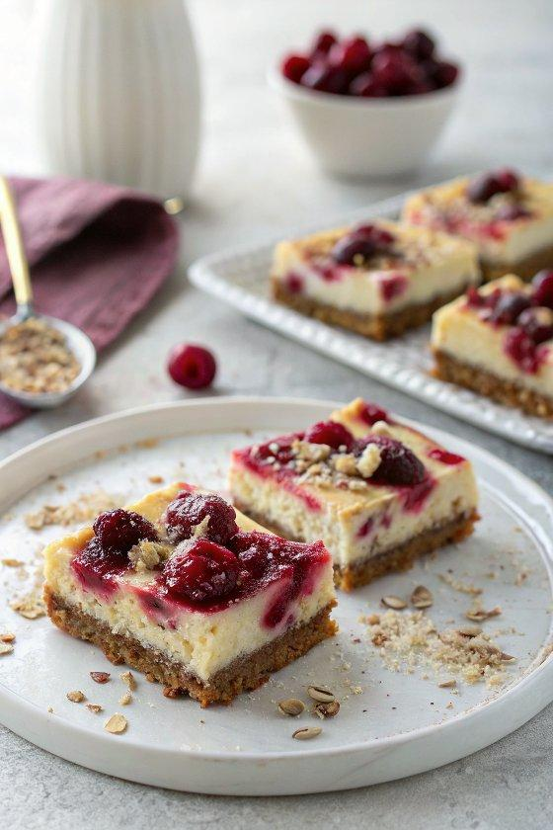

INGREDIENTS  - 3/4 cup fresh cranberries  - 1/4 cup sugar  - 1/4 cup water  - 1/2 tsp fresh orange zest  - 3 oz gingersnap crumbs (from 12 gingersnap cookie, I used Nabisco brand)  - 1 oz pecans (crushed)  - 1 1/2 tbsp light butter (melted)  - 8 oz 1/3 less fat cream cheese  - 1/4 cup sugar  - 1/2 tsp vanilla extract  - 6 oz nonfat Greek yogurt (Chobani)  - 2 egg whites  - 2 tbsp fresh lemon juice  - 1 tbsp flour | PREP  COOK  1. Preheat the oven to 350°F (175°C) and position a rack in the middle of the oven.  2. Line an 8x8-inch (20x20cm) baking pan with waxed paper, leaving a 2-inch (5cm) overhang on all sides.  3. Begin by preparing the cranberry sauce. Combine the cranberries, sugar, water, and orange zest in a small saucepan.  4. Cook together until the cranberries begin to burst and the mixture turns syrupy, about 6-7 minutes. Remove from the heat, allow to cool as you prepare the remaining ingredients.  5. Combine the gingersnap crumbs, crushed pecans, and light butter in a small bowl. Stir together to moisten the crumbs, then pour into the prepared baking pan. Spread in an even layer, using the bottom of a drinking glass to help ensure that the crust is even.  6. In a medium bowl, beat the cream cheese, sugar, and vanilla extract with an electric mixer until smooth. Add in the Greek yogurt, egg whites, lemon juice, and flour, mixing until just combined.  7. Pour the cheesecake mixture into the pan, over the crust, and smooth with a spatula.  8. Add the cooled cranberry mixture to a food processor, and puree until smooth. If the mixture is too thick, add 1/2 tablespoon water. Use a spoon to drop the cranberry sauce over the cheesecake, and then swirl the cranberry sauce with a butter knife.  9. Bake the cheesecake in the preheated oven for 25 minutes.  1  0. Allow the cheesecake to cool to room temperature, and place in the fridge for several hours to get well chilled. Once chilled, cut into squares and serve.  PLATING

