PEANUT & CHILI OIL CUCUMBER SALAD  COOK TIME: 25 min  SOURCE:  #quick #healthy #refreshing | 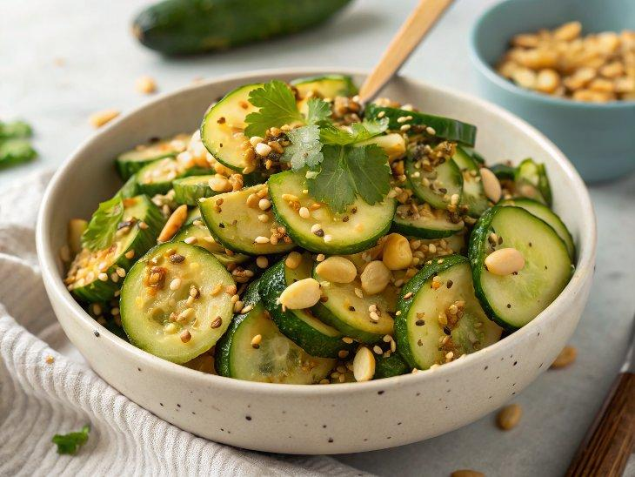

INGREDIENTS  - 9 mini cucumber  - 1/4 cup fresh cilantro  - 1/4 cup unsalted roasted peanuts  - 1 Tbsp toasted sesame seeds  - 3 Tbsp peanut butter  - 1 Tbsp reduced-sodium soy sauce  - 1/2 lime  - agave syrup  - 3/4 tsp garlic powder  - 1 Tbsp water  - 1 Tbsp chili crisp | PREP  COOK  1. Prep the cucumber, cilantro, and peanuts. Transfer to a bowl along with the sesame seeds.  2. Add all of the dressing ingredients to a small bowl and mix.  3. Pour the dressing over the salad and toss*. Let sit for at least 10 minutes for the flavours to infuse and for the cucumber to soften slightly .  4. Taste test and adjust the seasoning as desired. Plate, drizzle over the chili oil, and garnish with more cilantro, peanuts, and sesame seeds if desired. Enjoy!  PLATING

