EASY FRITTATA RECIPE (CHOOSE YOUR ADD-INS)  COOK TIME: 30 min  SOURCE:  #quick #comfort-food #egg-based | 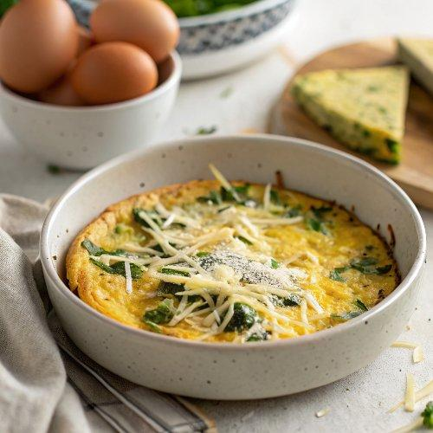

INGREDIENTS  - 8 large eggs  - 1/2 cup (120 ml) milk*  - 1/2 tsp salt, plus more for cooking vegetables  - 1/4 tsp ground black pepper, plus more for cooking vegetables  - 1 cup (about 100–120 g) shredded sharp cheddar cheese OR crumbled feta, divided  - 1 tbsp olive oil  - 2 cloves garlic, minced  - 1/2 small red onion, thinly sliced  - 1 heaping cup (about 150 g) chopped sweet potato (no need to peel)  - 1 heaping cup (130 g) sliced zucchini  - 1/2 cup (about 80 g) chopped red bell pepper  - optional for topping: chopped fresh parsley  - 1 cup (30 g) roughly chopped fresh spinach  - 1 cup (150 g) halved cherry tomatoes  - 1 heaping cup (about 160 g) canned quartered artichoke hearts, drained  - optional: 2 oz (56 g or about 4 slices) roughly chopped prosciutto | PREP  COOK  1. Preheat oven to 375°F (191°C).  2. In a medium bowl, preferably one with a pour spout, whisk together the eggs, milk, salt, and pepper. Whisk in about 3/4 cup of the cheese (cheddar for version #1/feta for version #2), reserving the rest for topping. Set aside.  3. Heat olive oil in a 2-inch (5cm)-deep, 10- to 12-inch (30cm)-diameter oven-safe skillet over medium heat. Add the garlic and cook, stirring, for about 30–60 seconds (don’t let it brown). Continue with either version below.  4. For the Garden Vegetable Frittata:  5. Add the red onion and sweet potato to the pan with the garlic. Cook for 5 minutes, stirring occasionally, until they begin to soften. Add the zucchini and red peppers, and season with salt and pepper. Cook for another 5 minutes, stirring occasionally.  6. Pour the egg-and-cheese mixture over the vegetables and cook for 5 minutes, without stirring, until bubbling/starting to set around the edges. Sprinkle the remaining 1/4 cup cheese on top.  7. Carefully transfer the skillet to the center rack of the oven, and bake for 22–26 minutes, or until the frittata is puffy and the center no longer wobbles/looks wet.  8. Transfer the skillet to a wire rack, and let it cool for at least 10 minutes before slicing and serving. Frittata will continue to set as it cools. Top with chopped fresh parsley, if desired.  9. For the Mediterranean-Inspired Frittata:  1  0. Fold the spinach, tomatoes, artichoke hearts, and prosciutto (if using) into the egg-and-cheese mixture.  1  1. Pour the egg-and-cheese mixture into the pan with the cooked garlic and cook for 5 minutes, without stirring, until bubbling/starting to set around the edges. Sprinkle the remaining 1/4 cup cheese on top.  1  2. Carefully transfer the skillet to the center rack of the oven, and bake for 22–26 minutes, until the frittata is puffy and the center no longer wobbles/looks wet.  1  3. Transfer the skillet to a wire rack, and let it cool for at least 10 minutes before slicing and serving. Frittata will continue to set as it cools.  PLATING

