BANGERS AND MASH RECIPE  COOK TIME: 25 min  SOURCE:  #comfort-food #hearty #traditional | 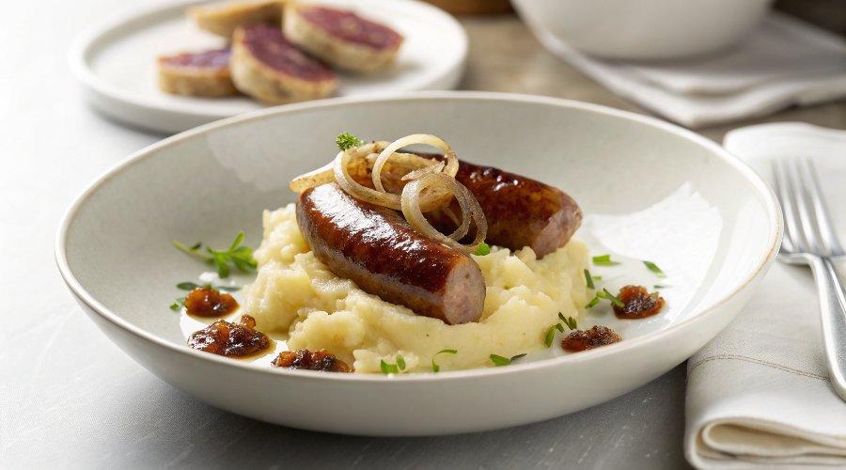

INGREDIENTS  - 2 tsp canola oil, divided ($0.04)  - 8 Pork sausage with casing* ($4.32/$0.54 each)  - 1 large yellow onion, julienned (sliced thinly) ($0.90)  - 1 tsp salt ($0.02)  - 1/4 tsp freshly cracked black pepper ($0.04)  - 3 cloves garlic, minced ($0.12)  - 1/2 Tbsp ground sage ($0.40)  - 2 cups (480ml) beef broth ($0.18)  - 1/8 cup flour, to thicken (as needed) ($0.02)  - half batch of our colcannon recipe** ($2.03) | PREP  COOK  1. Prep  2. You can simultaneously cook your colcannon while you prepare the bangers and onion gravy. Hop over to Beth’s recipe for mashed potatoes and cabbage to get it going!  3. Cook  4. Add 1 tsp canola oil to a large skillet over medium heat. Cook sausages until browned on all sides and internal temperature reads 160°F (70°C). Set aside on a covered plate while you make the onion gravy.***  5. Sauté  6. Add another teaspoon of canola oil, sliced onions, salt, pepper, and minced garlic to the sausage skillet (no need to wash it first!) and cook until glossy and beginning to soften.  7. Whisk  8. Add sage and beef broth to the skillet and whisk together to combine, integrating the bits of sausage and onions on the bottom of the skillet.  9. Thicken  1  0. When your onions are nice and soft, after about 8 minutes, make a slurry to thicken the gravy to your liking. To make a slurry, spoon out a small amount of the hot beef and onion broth into a small bowl and whisk in some of the flour until a smooth, loose paste forms.  1  1. Mix  1  2. Pour the slurry back into the onion gravy and whisk to combine. Repeat the slurry step if you want your gravy thicker, but know that the heat from the pan will help it thicken up with a little patience. I would add 2 Tbsp of flour at a time, no need to exceed 1/8 cup.  1  3. Check  1  4. You’ll know the gravy is the right consistency when it’s thick enough to coat the back of a spoon or takes a while to flow back to the center of the pan if you drag a spoon through it.  1  5. Serve  1  6. Scoop 1 cup (240ml) of colcannon onto each plate and place 2 sausages on top with generous spoonfuls of gravy. Keep it classic and serve with cooked peas on the side!  PLATING

