SHRIMP FRIED RICE  COOK TIME: 10 min  SOURCE:  #quick #comfort-food #fried-rice | 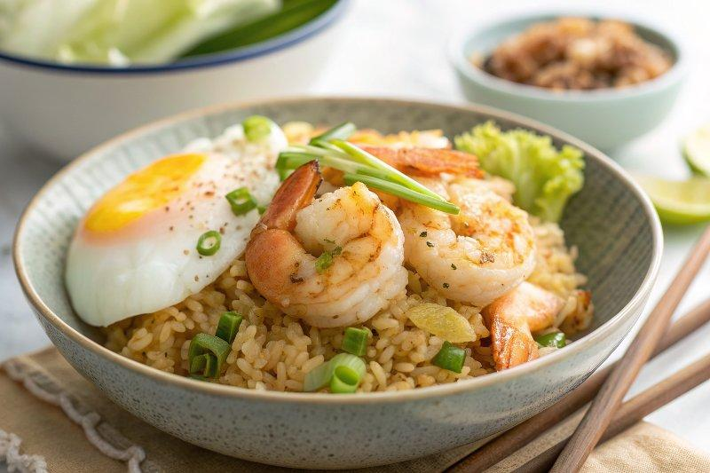

INGREDIENTS  - 4 oz shrimp (6 shrimp; shelled and deveined) 6  - 1 leaf iceberg lettuce (1 oz, 30 g) 1 30  - 1 green onion/scallion  - 2 Tbsp neutral oil  - 1 large egg (50 g each w/o shell)  - 1 tsp sake  - 1/4 tsp Diamond Crystal kosher salt  - 1 Tbsp toasted sesame oil  - 2 cups (480ml) cooked Japanese short-grain rice (preferably day-old cold rice)  - 1/8 tsp white pepper powder  - freshly ground black pepper  - 1 tsp soy sauce | PREP  COOK  1. Gather all the ingredients.  2. If your 4 oz shrimp are not shelled and deveined, please see my post How to Devein Shrimp. Then, cut the deveined shrimp into ½-inch (1.3-cm) pieces.  3. Cut 1 leaf iceberg lettuce and 1 green onion/scallion into small pieces.  4. Gently whisk 1 large egg (50 g each w/o shell) in a small bowl.  5. Heat a wok until the surface is almost smoking. Then, add 2 Tbsp neutral oil and spread it around until it coats the surface evenly. Add the egg and cook over high heat. The egg will not stick to the pan as long as you have added enough oil. Quickly mix it with a spatula. When it’s 80% cooked, transfer it to a plate.  6. In the same wok, add the shrimp pieces and then 1 tsp sake and ¼ tsp Diamond Crystal kosher salt. Cook until the shrimp pieces change color on the outside. The inside doesn’t have to be cooked through at this time. Remove the shrimp onto a plate.  7. Add 1 Tbsp toasted sesame oil and cook scallion, stir until nicely coated with oil.  8. Add 2 cups (480ml) cooked Japanese short-grain rice and break up the chunks of cold rice. Toss in the wok and mix well together.  9. When the rice is coated with oil, put the egg and shrimp back into the wok and toss it all together. Add the lettuce, ⅛ tsp white pepper powder, freshly ground black pepper, and 1 tsp soy sauce. Toss the fried rice in the wok frequently and mix it all together. Serve immediately.  PLATING

