SRIRACHA MAYO  COOK TIME: 3 min  SOURCE:  #quick #spicy #condiment | 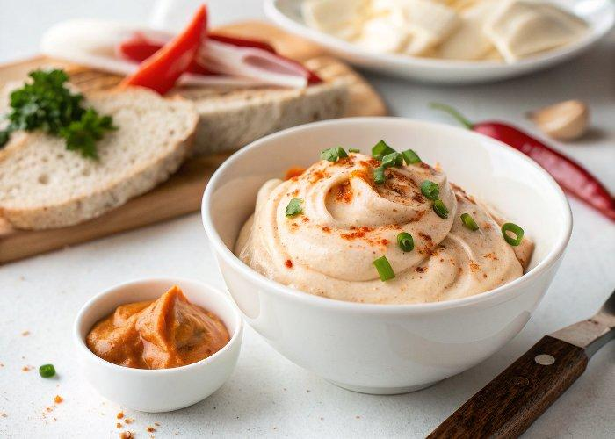

INGREDIENTS  - 6 Tbsp vegan mayonnaise  - 2 Tbsp sriracha | PREP  COOK  1. Mix together the mayo and sriracha in a bowl, and enjoy!  PLATING

