GOLDEN GRAHAM S'MORES BARS  COOK TIME: 1h  SOURCE:  #sweet #no-bake #comfort-food | 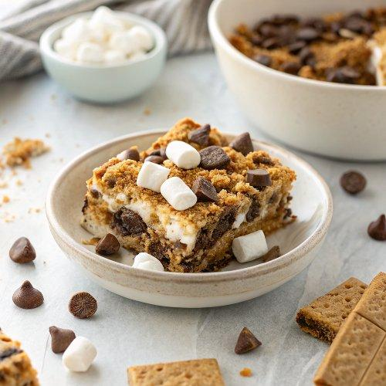

INGREDIENTS  - 1 bag (10.5 oz) miniature marshmallows (5 1/2 cups)  - 1 1/2 cups milk chocolate chips (9 oz)  - 5 tbsp butter or margarine  - 1/4 cup light corn syrup  - 1 tsp vanilla  - 1 box (13 oz) Golden Grahams cereal (8 cups) | PREP  COOK  1. Grease 13×9-inch (23cm) pan with butter. Reserve 1 cup (240ml) of the marshmallows. In a large saucepan, melt the chocolate chips, butter, corn syrup and remaining marshmallows over low heat. Stir until completely melted. Remove from heat; stir in vanilla.  2. Pour cereal into saucepan. Stir until coated with the melted chocolate mixture. Stir in remaining 1 cup (240ml) marshmallows.  3. With buttered back of spoon, press mixture in pan. Cool at least 1 hour or until firm. Store loosely covered at room temperature.  PLATING

