SICHUAN PEPPER BEEF BRISKET  COOK TIME: 3h 18m  SOURCE:  #comfort-food #slow-cooked #spicy | 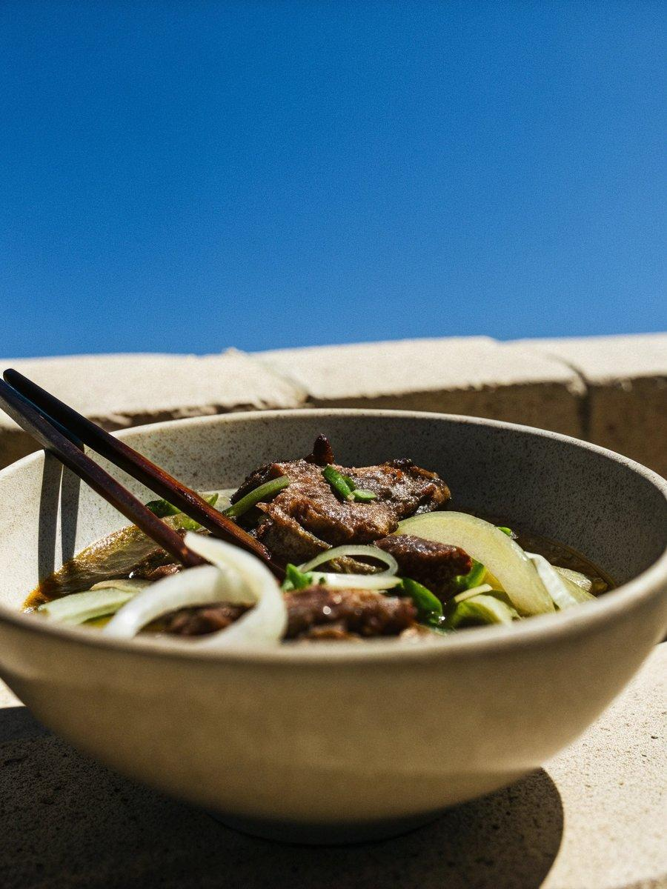

INGREDIENTS  - 2 large red onions  - 2 oranges  - 4 cloves of garlic  - 4cm (2-inch) piece of ginger  - 2 tbsp low-salt soy sauce  - 2 tbsp balsamic vinegar  - 2 tbsp runny honey  - 4 tsp Sichuan peppercorns  - 1 kg higher-welfare brisket, unrolled  - 4 tsp Chinese 5-spice  - olive oil  - 1 cucumber  - 6 nests of vermicelli rice noodles (300 g total)  - 1/2 a bunch of coriander (15 g)  - 2 tbsp toasted sesame seeds | PREP  COOK  1. Preheat the oven to 140°C/275°F (135°C)/gas  1. Peel and roughly chop the onions, place in a small high-sided roasting tray, then halve the oranges and squeeze in the juice. Peel, finely chop and scatter in the garlic and ginger, then drizzle in the soy, balsamic and honey and mix together.  2. Grind the Sichuan peppercorns in a pestle and mortar until fine, then rub all over the meat with the Chinese 5-spice, a pinch of sea salt and black pepper and a little olive oil. Sit the meat on top of the onions, cover tightly with tin foil, and roast for 3 hours, or until tender and pullable, adding splashes of water occasionally to prevent it from drying out, if needed.  3. Finely slice the cucumber into rounds, then toss with a pinch of salt and 2 tablespoons of red wine vinegar. Rehydrate the noodles according to the packet instructions, then drain well.  4. Remove the tray from the oven and discard the foil, then use forks to break the meat apart, tossing it back through the onions and tasty tray juices. Serve with the noodles, cucumber, picked coriander leaves and toasted sesame seeds, and let everyone help themselves. Nice with interesting cress or delicate seasonal leaves in the mix, too.  PLATING

