ASIAN CHICKEN WRAPS  COOK TIME: 15 min  SOURCE:  #quick #healthy #grilled | 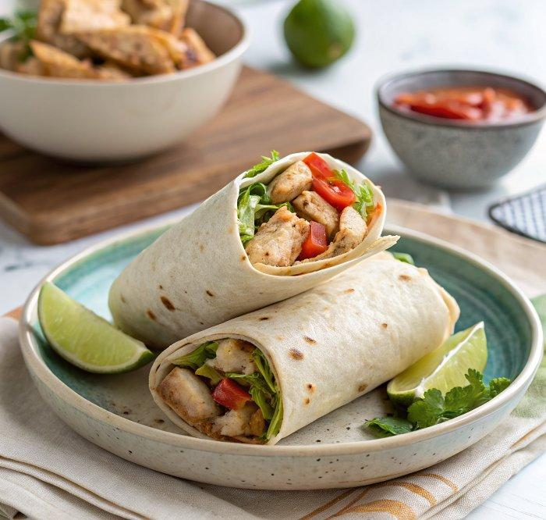

INGREDIENTS  - 1/3 cup creamy peanut butter  - 2 tbsp soy sauce  - 2 tbsp honey  - 1 tbsp Sriracha (or similar spicy chili sauce)  - 1 tbsp minced fresh ginger  - 1 tbsp fresh lime juice  - 1 lb boneless, skinless chicken breasts  - 1 tbsp canola oil (or grapeseed oil, divided)  - 2 cups (480ml) broccoli slaw  - 1 cup (240ml) shelled edamame (thawed if frozen)  - 1/2 cup shredded carrots  - 1/2 cup finely chopped green onions  - 1/4 cup dry roasted salted peanuts (chopped)  - Chopped fresh cilantro (to taste)  - 4 whole wheat tortillas | PREP  COOK  1. Stir  2. In a small bowl, stir together all of the sauce ingredients: peanut butter, soy sauce, honey, Sriracha, ginger, and lime. Set aside.  3. Sauté  4. Cut the chicken into bite-sized pieces. Heat half of the oil in a large, non-stick skillet over medium-high. Once the oil is shimmering, add the chicken (be careful as the oil may splatter), and sauté the chicken until fully cooked, about 2-3 minutes per side.  5. Sauce  6. Transfer to a bowl and blot away any excess oil. To the bowl, add 1/4 cup of the peanut sauce, then toss to coat the chicken. Reserve the rest of the sauce for serving.  7. Cook  8. To the same skillet in which you cooked the chicken, add the remaining oil and let warm for 30 seconds. Add the broccoli slaw, edamame, carrots, and half of the green onions and sauté until crisp-tender, about 2 minutes. Remove from heat.  9. Assemble  1  0. To assemble wraps, spread a spoonful of the reserved sauce on each tortilla.  1  1. Wrap  1  2. Top with the chicken, vegetables, chopped peanuts, remaining green onions, and fresh cilantro. Wrap and enjoy warm or at room temperature.  PLATING

