ROASTED STRAWBERRY RHUBARB AND YOGURT PARFAITS  COOK TIME: 20 min  SOURCE:  #quick #healthy #seasonal | 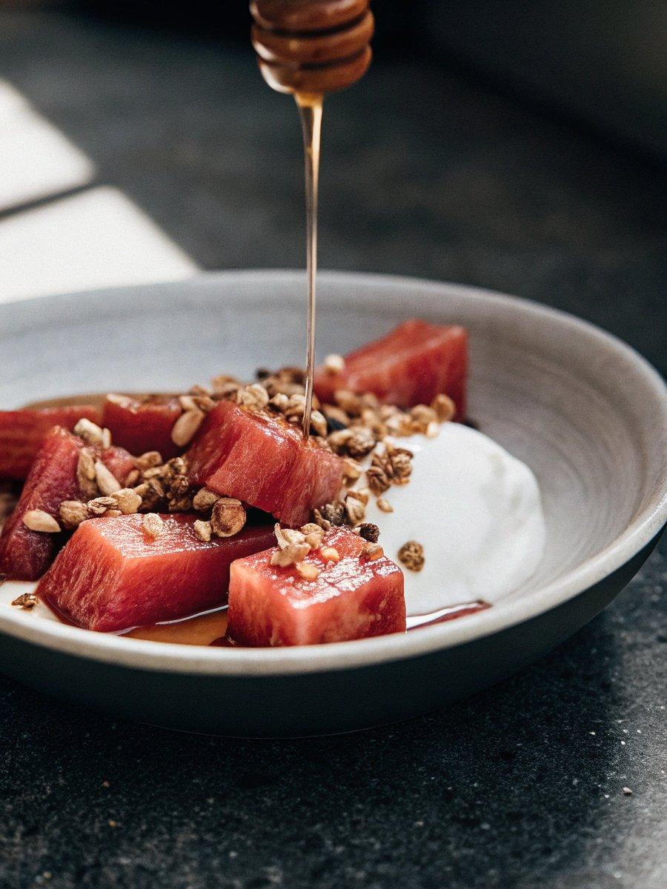

INGREDIENTS  - 1 lb strawberries, hulled and sliced into bite-sized pieces  - 1 lb rhubarb (about 4 stalks), cut into 1/4-inch (10cm) wide slices  - 1/3 cup honey  - 1 small lemon, juiced  - 1 batch of homemade honey almond granola, or several cups of store-bought granola (nut free if desired)  - 32 oz plain yogurt (Greek yogurt/vanilla yogurt works, too) | PREP  COOK  1. Preheat the oven to 350°F (175°C). Line a rimmed baking sheet with parchment paper.  2. On the baking sheet, toss the strawberry and rhubarb with the honey and spread the fruit into a single layer. Bake for about 20 to 25 minutes, tossing halfway, until fruit is tender and juicy. Watch the fruit on the edges of the pan, as the honey can burn quickly.  3. Transfer the fruit and the juices to a bowl. Stir in the lemon juice. Serve warm over ice cream or cheesecake or let it cool and swirl it into a milkshake, etc.  4. If you want to make parfaits: in small glasses or bowls, layer yogurt, strawberry-rhubarb sauce and granola to your liking.  PLATING

