CHINESE BEEF MEAT PIE (XIAN BING, 牛肉馅饼)  COOK TIME: 20 min  SOURCE:  #comfort-food #savory #meat | 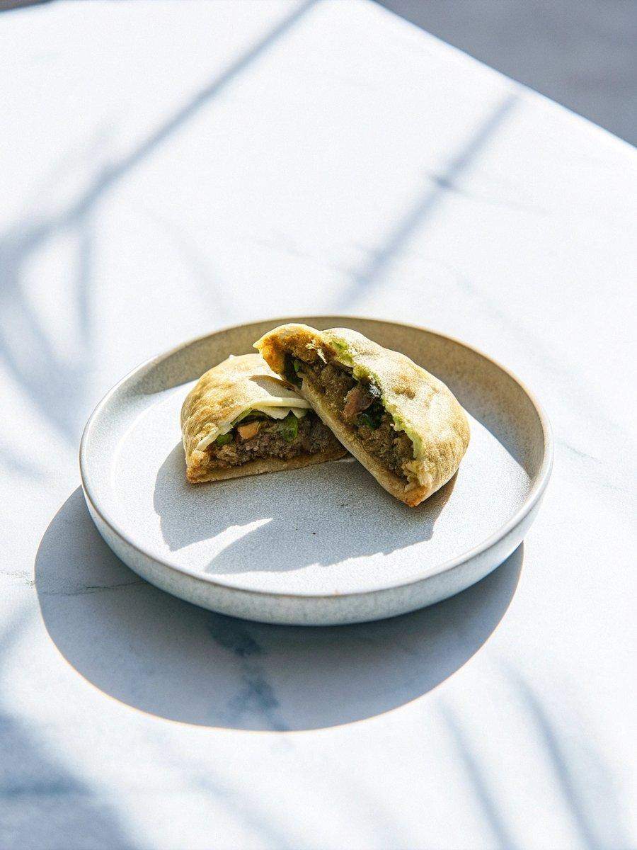

INGREDIENTS  - 450 g (about 3 cups) all-purpose flour , plus extra to coat hands  - Pinch of salt  - 3/4 cup hot water  - 1/2 cup cold water  - 12 oz ground raw beef (lean fat ratio 8:2)  - 1 tbsp minced ginger  - 1 tbsp Shaoxing wine (or dry sherry)  - 1 tbsp light soy sauce  - 2 tsp dark soy sauce  - 1/4 tsp freshly ground Sichuan peppercorn (or black pepper)  - 1 onion , minced  - 1 large carrot , grated  - 1 tsp sugar  - 1 1/4 tsp salt  - 1 tbsp toasted sesame oil  - 1 tbsp vegetable oil plus extra for cooking | PREP  COOK  1. Combine flour and a pinch of salt in a big bowl (or the bowl of a mixer if using) and stir to mix well. Slowly pour hot water onto the dried flour and use a pair of chopsticks to stir until the water is fully incorporated. Then slowly add the cold water onto the dry flour, and keep mixing, until the water is fully incorporated and it forms small dough pieces with no or little dry flour left.  2. (Option 1) Using a mixer: Attach the dough hook and turn to medium speed (speed 4). Mix until a smooth and spring dough has formed, 8 minutes.  3. (Option 2) Knead the dough by hand: Use your hand to gather and press the dough flakes together to form a dough. If there is too much dry flour in the bowl and it is difficult to blend into the dough, add a bit more water to the dry flour, 1 teaspoon at a time. Knead until there is no dry flour left. The dough should feel soft but you should be able to easily pick it up without it sticking to your hands and the bowl too much. If the dough is too soft, you can sprinkle it with more flour. Transfer the dough onto a clean working surface and keep kneading, until the dough turns smooth and springy, 10 to 15 minutes.  4. Transfer the dough to a medium-sized bowl. Seal the bowl with plastic wrap. Let rest for at least 1 hour, or up to 3 hours. The longer you rest the dough, the easier it will be to work with later. If you plan to store the dough overnight, store the covered bowl in the refrigerator.  5. To make the filling  6. Prepare the filling while resting the dough. Combine ground beef, minced ginger, Shaoxing wine, light soy sauce, dark soy sauce, and ground Sichuan peppercorn (or black pepper) in a big bowl. Mix well until the liquid ingredients are fully absorbed and the meat has turned into a sticky paste. If the paste feels very dry and is hard to mix, add 2 tablespoons of water and mix again until the water is fully incorporated. (*Footnote 1)  7. Prepare and cut the vegetables, but do not add them to the ground beef yet.  8. Right before assembling the pies, add the onion, carrot, salt and sugar to the beef filling. Mix well. Add sesame oil and mix again. (*Footnote 2)  9. To assemble the pies  1  0. Add 1 tablespoon of oil into a small bowl. Prepare a small brush. And some extra flour on the side.  1  1. Transfer the dough onto a clean working surface. The dough should now have turned a bit softer and smoother.  1  2. Divide the dough into two equal pieces and put one piece back in the bowl and cover it with plastic wrap. Roll the other half into a ball. Press it slightly so it’s easier to roll out. Use a rolling pin to roll it into a thin round disc, about 1/8” (3 mm) thick, 12” (30 cm) long and 10” (25 cm) wide.  1  3. Brush a very thin layer of oil on top. Sprinkle about 1/2 tablespoon of flour evenly over the dough and brush it again until evenly spread. Roll the round dough sheet from the bottom into a long stick. Cut the stick into 6 equal pieces.  1  4. Work on the meat pies one at a time. Cover the rest of the dough with plastic wrap.  1  5. Pinch the two ends of each piece of the roll to seal the oil inside. Place the dough on the working surface, with the two pinched ends pointing on the sides. Press the dough gently and form it into a round shape. Roll the dough until it forms a thin round disc, about 1/8” (3 mm) thick and 7” (18 cm) in diameter. This step helps to create a layered crust.  1  6. Scoop 2 to 3 tablespoons of beef filling and place it on one side of the disc, in a half-moon shape.  1  7. Fold the empty half over and press the edges together by hand. Turn the edge upward and press it again to further seal the pie.  1  8. Set the pie aside on a large tray or plate, brush a thin layer of oil on top, cover with plastic wrap, and work on the rest of the dough in the same manner.  1  9. To cook the pies  2  0. Heat a large nonstick skillet with 2 tablespoons of oil over medium heat until hot, but not smoking hot. Transfer meat pies to the skillet without overlapping and press down with a spatula gently, to flatten the bottom for maximum crispy crust. Cover the skillet and cook over low heat until the bottom side turns golden brown, 3 minutes or so. Uncover and check the meat pie after 2 minutes, to make sure it’s not browning too fast. Once browned, flip with a spatula and cook the other side. Cover and cook until the bottom side turns golden brown, 3 minutes. Then you can flip the meat pie again if you wish to brown any sides a bit longer. Cook without cover for another minute or so until both sides are golden brown. Transfer the meat pies to a larger plate. Cook the remainder of the meat pies the same way.  2  1. Serve hot with Chinese black vinegar. If the meat pie is not salty enough, blend 1 teaspoon light soy sauce with 1 tablespoon black vinegar as a dipping sauce.  2  2. To store the meat pie  2  3. Place meat pie in an airtight container. Store in the fridge for up to 3 days or in the freezer for 3 months.  2  4. To reheat the meat pie. Heat oil in a skillet over medium heat until warm. Add meat pies and turn to low heat. When the skillet is hot, add 2 to 3 tablespoons of water and cover immediately. Flip once during the cooking. Cook until both sides are crispy and the inside is hot, 3 to 4 minutes. You can cook the frozen meat pies the same way, but you will need another 8 minutes to cook through the inside. You can also heat up the frozen cooked meat pies in a preheated oven, around 350°F (176°C) until crispy and warmed through, 15 minutes or so.  PLATING

