BAKED EGG IN A BASKET  COOK TIME: 20 min  SOURCE:  #quick #comfort-food #breakfast | 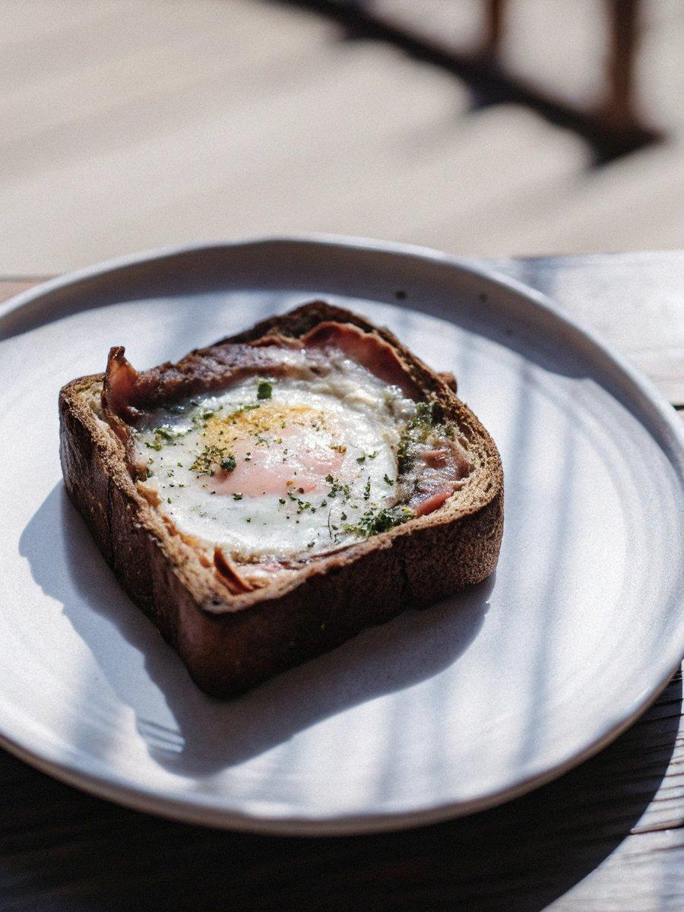

INGREDIENTS  - 2 slices white bread  - 1 egg  - 2 Tbsp mayonnaise  - 1/2 slice ham (or 1 rindless bacon rasher)  - A pinch fine sea salt  - 1 slice cheese (optional)  - A pinch parsley (optional) | PREP  COOK  1. Preheat the oven to 180ºC / 356F.  2. Cut the ham/bacon rasher into 4 small square pieces for a simple Korean flag version (per TV program). Alternatively, you could slice the ham/bacon into the real Korean flag stripes.  3. Place one slice of bread on a board. Squeeze and spread mayonnaise with a spread knife thoroughly on one side.  4. Place another slice of bread on a board. Make a round hole on the bread using a round shaped cookie cutter or any round shaped object that’s strong and sharp enough to cut through the bread. (I used 1/2 cup stainless steel measuring cup.)  5. Place the bread slice (with a hole) from step 4 on top of the mayo spread bread slice from step  3. (Optionally, you could insert a slice of cheese in between the bread for a more savory cheesy taste.)  6. Squeeze the mayonnaise around the edge of the top bread slice.  7. Break the egg in the hole and sprinkle a pinch of salt on the egg. (Optionally, you could also add a pinch parsley on the egg.) Place the ham/bacon on the four corners of the bread.  8. Cook the bread in the oven for 20 mins. (If you prefer slightly runnier egg white and yolk, cook it for 15 mins or less.)  9. Serve. (It tastes great with a cup of fresh fruit juice.)  PLATING

