VEGETARIAN PORTOBELLO POT ROAST  COOK TIME: 4h  SOURCE:  #comfort-food #hearty #vegetable | 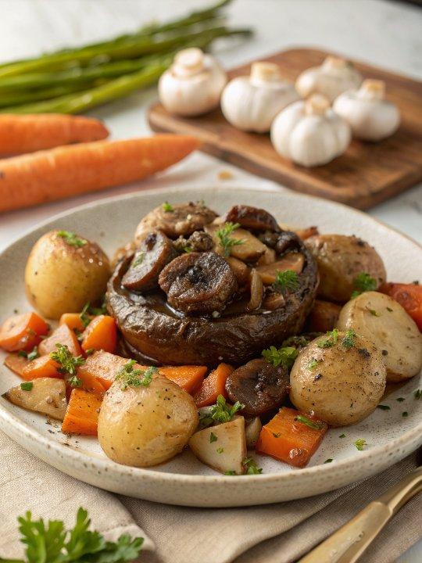

INGREDIENTS  - 1.25 lb Yukon gold potatoes, cut into bite-sized pieces  - 1 lb baby bella mushrooms (if they are large, cut them in half)  - 2 large carrots, peeled and cut into bite-sized pieces  - 2 cups (480ml) frozen pearl onions*  - 4 cloves garlic, peeled and minced  - 3 sprigs fresh thyme  - 3 cups (720ml) vegetable stock, divided  - 1/2 cup dry red or white wine  - 3 tbsp tomato paste  - 2 tbsp vegetarian Worcestershire sauce*  - 2 tbsp cornstarch  - Kosher salt and freshly-cracked black pepper  - optional garnish: finely-chopped fresh parsley | PREP  COOK  1. Slow Cooker Method:  2. Add potatoes, mushrooms, carrots, onions, garlic, thyme, 2.5 cups (1200ml) vegetable stock, wine, tomato paste and worcestershire together in the bowl of a crock pot, and gently toss to combine. Cook on low for 6-8 hours, or on high for 3-4 hours, until the potatoes and carrots are tender.  3. In a separate bowl, whisk together the remaining 1/2 cup vegetable stock and cornstarch until combined. Add to the roast mixture, and gently toss to combine. Continue to cook for 1-3 minutes, until the sauce thickens up a bit.  4. Serve immediately, garnished with fresh parsley if desired.  5. Instant Pot Method:  6. Add potatoes, mushrooms, carrots, onions, garlic, thyme, 2.5 cups (1200ml) vegetable stock, wine, tomato paste and worcestershire together in the bowl of a pressure cooker, and gently toss to combine. Close lid securely and set vent to “Sealing”.  7. Press “Manual”, then press “Pressure” until the light on “High Pressure” lights up, then adjust the up/down arrows until time reads 20 minutes. Cook. Then let the pressure release naturally, about 15 minutes. Carefully turn the vent to “Venting”, just to release any extra pressure that might still be in there. Remove the lid.  8. In a separate bowl, whisk together the remaining 1/2 cup vegetable stock and cornstarch until combined. Add to the roast mixture, and gently toss to combine. Continue to cook for 1-3 minutes, until the sauce thickens up a bit.  9. Serve immediately, garnished with fresh parsley if desired.  PLATING

