EASY VEGAN PIE CRUST  COOK TIME: 15 min  SOURCE:  #quick #comfort-food #baking | 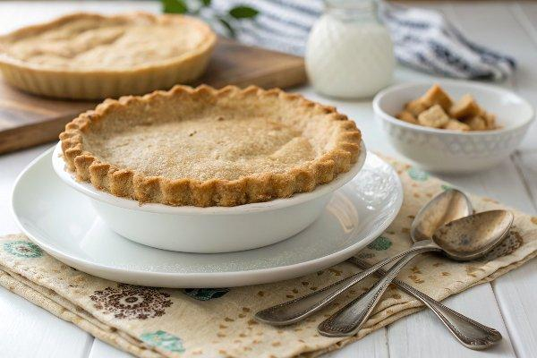

INGREDIENTS  - 1 1/2 cups all purpose flour (spooned and leveled)  - 1 tsp sugar  - 1/4 tsp salt  - 1/4 cup vegan butter, cold and cut into cubes  - 1/4 cup vegetable shortening, cold and into a few pieces  - 3-4 tbsp ice water | PREP  COOK  1. Make sure your vegan butter and shortening are very cold before starting. Refrigerate along with the shortening for at least 30 minutes.  2. Add flour, sugar and salt to food processor with the "S" blade. Pulse a few times to combine.  3. Add cold vegan butter and shortening. Process for about 10 seconds, until it looks like a coarse meal (see photos above for reference).  4. Now while the food processor is running, drizzle in 3 tablespoons of ice cold water. When it begins to clump together, stop. You may need to add 1 more tablespoon ice water for it to come together.  5. Dump the dough onto a lightly floured surface and shape it into a ball. Don't use your hands too much or it will warm the dough, which will make your pie crust less flaky and light.  6. Roll the dough with a rolling pin to about a 12-inch (30cm) circle, and transfer to a pie plate. I usually wrap it gently around my rolling pin and then carefully transfer it. Don't panic if it's not perfect, you can fix it in the pie plate!  7. Gently push the pie crust all around the dish, trimming off any excess and replacing any spots that need repair. See this tutorial for fluting the edges and making other special pie edges.  8. It's now ready to use immediately, or refrigerate until you are ready to use. Simply double the recipe for 2 pie crusts (top and bottom).  9. To make by hand:  1  0. If you don't want to use a food processor, you can make the pie crust by hand. Simply whisk together the dry ingredients in a large bowl, then add the cold butter and shortening. Use a pastry cutter or fork to cut it in, then drizzle in the ice water and stir until the dough comes together.  1  1. How to pre-bake a pie crust  1  2. For a recipe that calls for a pre-baked pie crust, follow these instructions. If possible, freeze the pie crust lined in the pie plate for 30 minutes. This will help it not shrink down when it bakes.  1  3. Preheat the oven to 350°F (175°C). Once the crust has been frozen for 30 minutes, line it with aluminum foil or parchment paper (foil is easier to work with). Fill the crust to the top with sugar, or dried beans, pie weights or rice.  1  4. Place in the oven and bake for 15 minutes for a pie that will cook further in the oven. For no-bake filling pies, bake for 15 minutes with the pie weights, then carefully remove them and bake the crust for 15 more minutes, until golden. Cool before filling.  1  5. Instructions for baking pie crust will depend on the pie's specific recipe, but these are general instructions for pre-baking pie crust.  PLATING

