LEMON GARLIC BUTTER SHRIMP  COOK TIME: 10 min  SOURCE:  #quick #comfort-food #seafood | 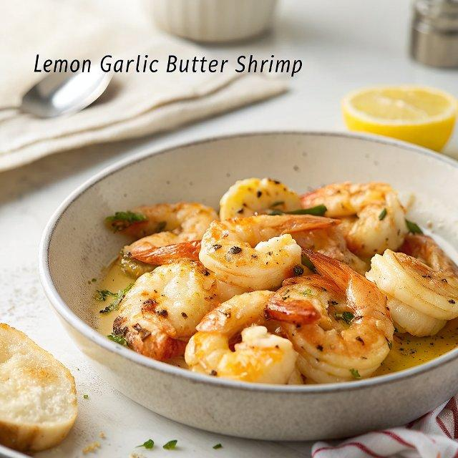

INGREDIENTS  - 1/3 cup butter (divided)  - 4 cloves garlic (minced, or 1 tbsp)  - 1 3/4 lb shrimp (or prawns, peeled and deveined, tails intact)  - 1 pinch Kosher salt (to taste)  - 1 pinch freshly ground black pepper (to taste)  - 1-2 tbsp lemon juice (juice of half a lemon - add more if desired)  - 2 tbsp water  - 1 pinch fresh parsley (chopped to garnish) | PREP  COOK  1. Melt 2 tablespoon butter in a large skillet over medium-high heat. Add the garlic and cook until fragrant (about 1 minute).  2. Fry shrimp and add salt and pepper, to your taste. Cook 2 minutes on one side, while stirring occasionally. Flip and cook 2 minutes on the other side until JUST beginning to turn pink.  3. Add in the remaining butter, lemon juice and water. Cook, while stirring, until the butter melts and the shrimp have cooked through (do not over cook them). Take off heat. Taste test, and add more lemon juice, salt or pepper, if needed to suit your tastes.  4. Garnish with fresh chopped parsley and serve over rice or pasta.  PLATING

