CHOCOLATE MUFFINS  COOK TIME: 20 min  SOURCE:  #quick #comfort-food #baking | 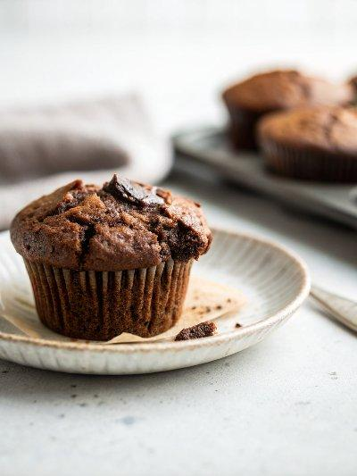

INGREDIENTS  - 2 large eggs  - 1 cup (240ml) low-fat buttermilk (see note)  - 2 tsp vanilla extract  - 1 3/4 cups all-purpose flour, (spooned into measuring cup and leveled-off)  - 2/3 cup natural unsweetened cocoa powder, (such as Hershey's)  - 1 1/4 cups (packed) light brown sugar  - 1 tsp baking powder  - 1 tsp baking soda  - 1/2 tsp salt  - 1 cup (240ml) semi-sweet or bittersweet chocolate chips  - 1/2 cup (1 stick) unsalted butter, melted and cooled slightly | PREP  COOK  1. Position a rack in the center of the oven and preheat to 425°F (220°C). Line a standard 12-cup muffin pan with paper liners.  2. In a large measuring cup or bowl, whisk together the eggs, buttermilk, and vanilla extract.  3. In another large bowl, whisk together the flour, cocoa powder, brown sugar, baking powder, baking soda, and salt. Rub the mixture through your fingers to break up any lumps of brown sugar.  4. To the dry ingredients, add ¾ cup (115 g) of the chocolate chips, the buttermilk-egg mixture, and the melted butter. Using a rubber spatula or wooden spoon, mix until just combined.  5. Using an ice cream scoop or two spoons, fill the muffin cups to the brim with batter. Distribute the remaining ¼ cup (40 g) of chocolate chips evenly over the muffin tops, pressing them lightly into the batter. Place in the oven and bake for 8 minutes, then turn the oven down to 350°F (175°C) and bake for about 12 minutes more, or until a toothpick inserted in the center of a muffin comes out clean (check a few spots as the melted chocolate chips will make the tester look wet). Transfer to a wire rack and let cool for about 5 minutes before removing the muffins from the pan; cool on a rack.  PLATING

