MOO SHU PORK, THE ORIGINAL RECIPE (木樨肉)  COOK TIME: 8 min  SOURCE:  #stir-fry #comfort-food #quick | 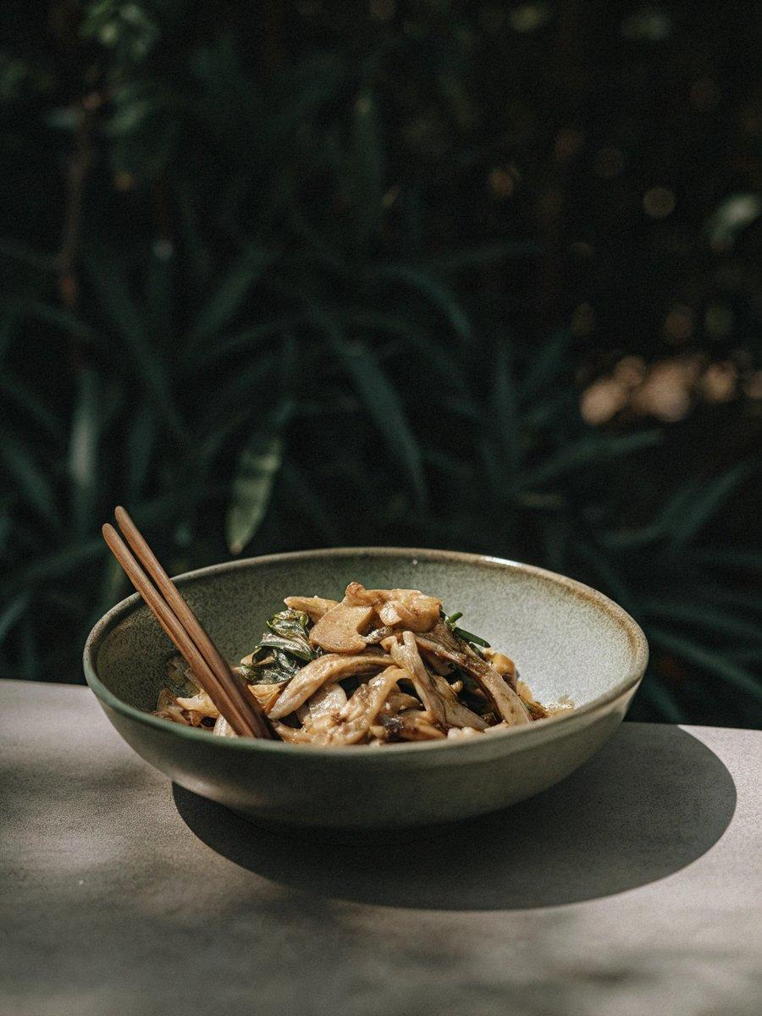

INGREDIENTS  - 150 g pork tenderloin (see note 1)  - 1 tbsp Shaoxing rice wine  - 2 1/2 tbsp neutral cooking oil, divided  - 3 medium eggs, lightly beaten (or 2 large eggs)  - 50 g wood ear mushroom (5 g in dried form), rehydrated & torn into small pieces (see note 2)  - 20 strands lily buds, rehydrated & cut in half crosswise (see note 3)  - 80 g cucumber, sliced  - 2 stalks scallions, finely chopped  - 1 tsp minced ginger  - 1 tbsp light soy sauce  - 1/4 tsp salt (or to taste)  - 1 pinch ground white pepper | PREP  COOK  1. Cut the pork against the grain into thin slices (if you find it difficult, put the pork in the freezer for 1-2 hours until semi-frozen then slice). Add Shaoxing rice wine. Mix until fully absorbed.  2. Heat 1 tbsp of oil in a wok over high heat until it starts to smoke. Pour in the egg. When the edge is cooked, push to one side to let the uncooked part flow to the centre of the wok. Break the cooked egg into bite-sized pieces with a spatula. Transfer to a plate.  3. Add another 1 tbsp of oil to the wok. Stir fry the pork. Transfer to the egg plate as soon as it turns pale (do not overcook).  4. Pour the remaining 1/2 tbsp of oil into the wok. Fry scallions and ginger for 20 sec or so then add wood ear and lily buds. Stir fry for 30 sec then put in cucumber.  5. Once the cucumber begins to wilt, add the egg and pork. Season with light soy sauce, salt and white pepper. Stir fry for 10 more sec then dish out. Serve immediately.  PLATING

