MUSTARD POTATO SALAD, MEDITERRANEAN-STYLE  COOK TIME: 6 min  SOURCE:  #quick #healthy #refreshing | 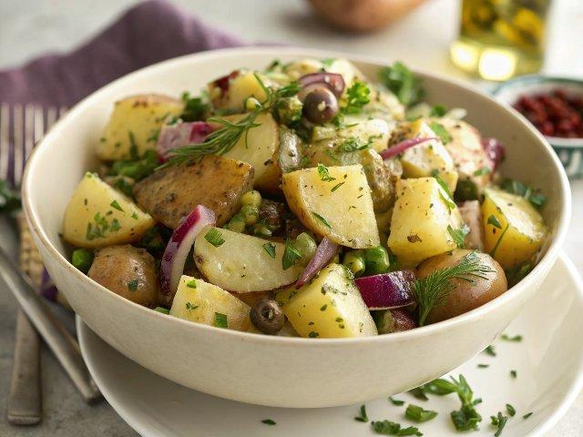

INGREDIENTS  - 1 1/2 lb small potatoes (such as new potatoes, Yukon gold potatoes, or red potatoes)  - Water  - tsp salt  - 1/4 cup chopped red onions  - 1/4 cup fresh chopped parsley  - 1/4 cup chopped dill  - 2 tbsp capers  - 1/3 cup extra virgin olive oil  - 2 tbsp white wine vinegar  - 2 tsp Dijon mustard  - 1/2 tsp ground sumac  - 1/2 tsp black pepper  - 1/4 tsp ground coriander | PREP  COOK  1. Wash and scrub the potatoes and dry them well. Slice potatoes thinly using a mandoline slicer. I used this slicer (affiliate link).  2. Place potatoes in a pot and add water to cover by 1-inch (3cm). Bring to a boil. Add salt. Turn the heat down and allow the potatoes to simmer for about 6 minutes or so until they're tender (you should be able to poke the potatoes with a fork).  3. Add vinaigrette ingredients to a small bowl and whisk until well-combined.  4. When the potatoes are ready, remove from heat and drain well. Place them in a large mixing bowl and immediately dress them with the Dijon mustard dressing. Gently toss to coat.  5. Add onions, fresh herbs, and capers. Toss gently to combine.  6. Transfer the potatoes to a serving platter. For best results, allow the potato salad some time to marinade before serving. You can refrigerate it for 1 hour or so but be sure to bring it to room temperature before serving.  PLATING

