CARNE ASADA  COOK TIME: 10 min  SOURCE:  #grilled #comfort-food #quick | 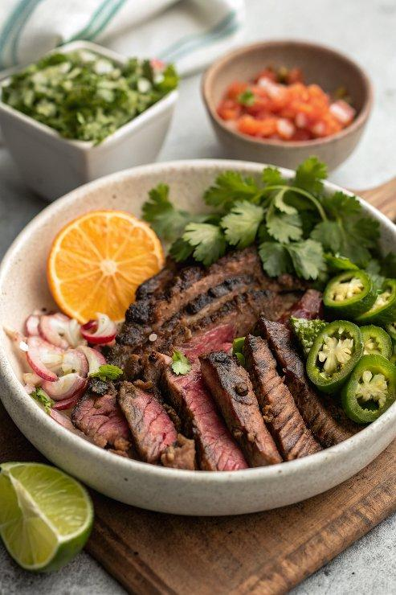

INGREDIENTS  - 2 garlic cloves  - 1 fresh jalapeno (halved, stemmed, and seeded*)  - 1 bunch fresh cilantro (including leaves and tender stems)  - 1 lime (juiced (about 2 tbsp)  - 1 orange (juiced (about 1/4 cup)  - 2 tbsp extra-virgin olive oil  - 1 tsp chili powder  - 1/2 tsp ground cumin  - 1 tsp kosher salt  - 2 lb flank or skirt steak | PREP  COOK  1. Blend  2. In a blender or small food processor, pulse the garlic, jalapeno, cilantro, lime juice, orange juice, olive oil, chili powder, cumin, and salt.  3. Marinate  4. Place the steak in a zip-top bag or an airtight container and cover with the marinade. Seal and turn to coat. Refrigerate for at least 4 hours and up to 12 hours (do not marinate longer or the meat will start to break down).  5. Warm  6. Forty-five minutes prior to cooking, remove the steak from the refrigerator to allow to come to room temperature.  7. Grill  8. Preheat half of a gas or charcoal grill to high heat (preheating only half will keep the grill from getting *as* hot). Clean the grates if necessary. Place the steak over the heat, cover, and cook until the center reaches 110°F (45°C) on an instant-read thermometer, turning the steak every few minutes, about 3-5 minutes per side total (that’s 6 to 10 minutes total for the whole steak; DO NOT overcook!). Transfer the steak to a cutting board and rest for 5 minutes. Cut across the grain into very thin strips.  PLATING

