VEGAN PEPPER BLACK BEAN STIR-FRY  COOK TIME: 10 min  SOURCE:  #quick #stir-fry #healthy | 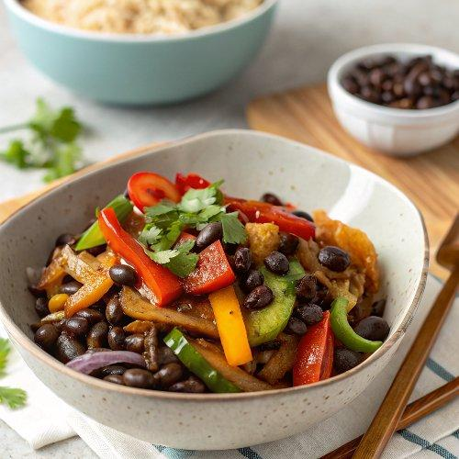

INGREDIENTS  - 1/2 cup water  - 1/4 cup soy sauce ((gluten-free if preferred))  - 2 tbsp cornstarch  - 1 tbsp rice vinegar  - 1 1/2 tsp brown or white sugar  - 1/4 tsp liquid smoke  - 1 tbsp light oil ((such as canola or vegetable))  - 2 bell peppers (any colour) (thinly sliced)  - 4 cloves garlic, (minced)  - 2-inch (5cm) fresh ginger (minced)  - 1 19 oz can black beans, (drained and rinsed (2 cups))  - green onions and sesame seeds, for garnish ((optional)) | PREP  COOK  1. Make the sauce: Add all of the sauce ingredients to a medium bowl or large measuring cup and whisk well to combine. Set aside.  2. Make the pepper black beans: Heat the oil in a large skillet over medium-high heat, when hot add the peppers and cook for about 2 minutes. Add the garlic and ginger and cook another 5 minutes, stirring often until the peppers start to soften and begin to brown.  3. Add the black beans and all of the sauce to the pan and stir, cooking another few minutes until the sauce thickens and coats the veggies, and the beans are heated through. If the sauce gets too thick, just stir in a splash of water as needed. Serve hot over rice and garnish with green onions and sesame seeds if desired.  PLATING

