HEALTHIER CHICKEN AND ZUCCHINI NOODLE CASSEROLE.  COOK TIME: 45 min  SOURCE:  #healthy #casserole #comfort-food | 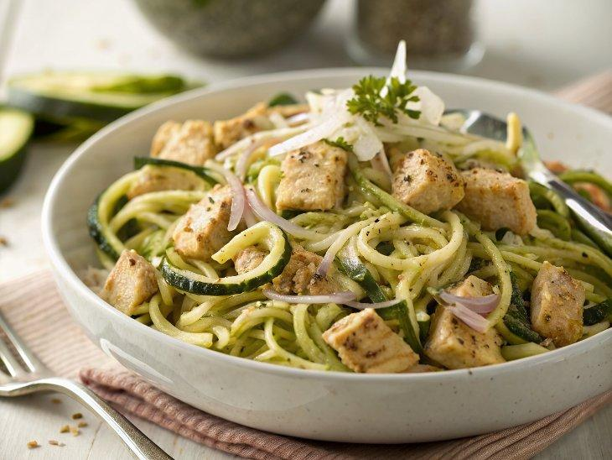

INGREDIENTS  - 3 cups (720ml) grated zucchini (about 3 medium zucchini's)  - salt  - 6-8 slices thick whole grain bread*  - 3/4 lb boneless (skinless, chicken tenders, diced)  - 1/2 of a small onion (grated)  - 2 cloves garlic (minced or grated)  - 1 carrot (grated)  - 1/2 lb dry egg noodles * (about 4-6 oz, optional)  - 1 tsp dried thyme  - 2 tsp dried parsley  - 1/2 tsp cayenne pepper  - salt + pepper (taste)  - 1 cup (240ml) gouda cheese (shredded)  - 2-3 cups (720ml) chicken broth  - 1/2 cup dry white wine (or more chicken broth)  - 1 cup (240ml) plain greek yogurt  - 6 tbsp butter (melted)  - 2 eggs  - 1 1/2 cups crushed cornflakes. Can sub potato chips (Ritz Crackers or even use a mix of all three) | PREP  COOK  1. Preheat the oven to 375°F (190°C).  2. Lay a clean kitchen towel on the counter and spread the grated zucchini out in a single layer. Sprinkle the zucchini with a little salt and then cover the zucchini with another clean towel. Let sit at least 10 minutes.  3. Meanwhile, grease a 9x13-inch (23x33cm) baking dish.  4. To the bottom of the baking dish, add the cubed bread, making sure the bread mostly covers the bottom of the dish. Add the chicken, grated onion, garlic, carrot, dried noodles, thyme, parsley, cayenne and a pinch of salt + pepper. Sprinkle the gouda cheese on top and add the zucchini. Add in the chicken broth (starting with 2 cups), wine, greek yogurt, butter and eggs.  5. Using clean hands (I prefer using my hands) or a spatula, mix all the ingredients up until the bread is well moistened and everything is evenly distributed. If the mixture seems dry, add more broth until well moistened. Sprinkle the corn flakes over top the dish, cover with foil and bake on the middle rack for 30 minutes. After 30 minutes, remove the foil and continue baking for 25-30 minutes or until the top is lightly golden and the casserole is no longer jiggly. Remove and let sit 5 minutes before serving.  6. Serve with fresh herbs if desired. YUM!  PLATING

