SPICY CHIPOTLE TURKEY BURRITOS (MAKE AHEAD)  COOK TIME: 30 min  SOURCE:  #spicy #comfort-food #make-ahead | 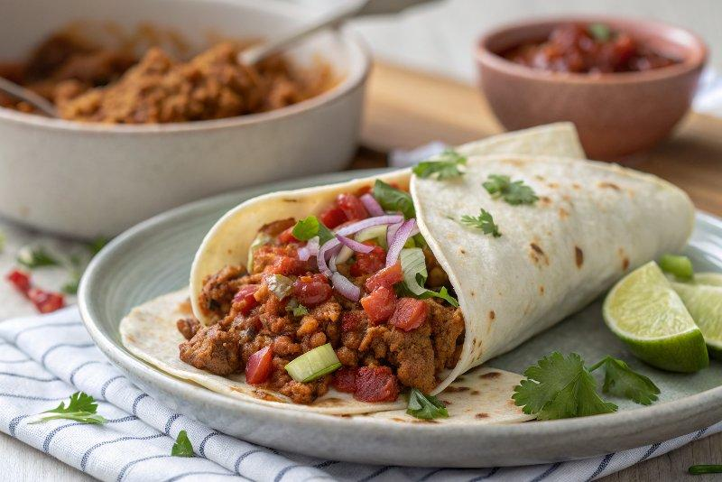

INGREDIENTS  - 1 tbsp oil  - 1/2 onion, minced  - 3 lbs. ground turkey  - 2 tbsp EACH chili powder and cumin  - 3-5 individual chipotle peppers (canned in adobo sauce), minced  - 2 tsp salt  - 1 tbsp oil  - 1/2 onion, minced  - 1 tbsp EACH chili powder and cumin  - 4-5 cups (1200ml) chopped veggies like carrots, zucchini, sweet potatoes, bell peppers, etc. (see notes for specifics)  - 1 cup (240ml) chicken broth (more as needed)  - 1 14-oz can pinto or black beans  - 2 cups (480ml) shredded Mexican blend cheese  - 1 1/2 cups plain Greek yogurt  - 15 10-inch (25cm) tortillas  - avocado, hot sauce, cilantro, etc. for serving | PREP  COOK  1. Filling Part One: Heat the tablespoon oil in a large Dutch oven or stock pot. Add the onion and the turkey; as the turkey cooks, add the spices, chipotle peppers, and salt. Cook until the turkey is browned and fully cooked. When the meat is saucy and delicious-looking, transfer to a large bowl and set aside.  2. Filling Part Two: In the same pot, add the oil, onion, veggies, and spices. Saute for a few minutes until the vegetables are mostly soft. Add enough broth to barely cover the vegetables and simmer for 10 minutes or so, until the vegetables are soft and the mixture has thickened. Add the beans, meat, cheese, and yogurt. Stir until creamy. Also at this point it’s a good idea to taste and add salt or more seasoning to make sure you’re all good on flavor.  3. Fill each tortilla with about 1/2 cup of the filling, fold up (I spread a little goat cheese or avocado on the sides to help them stick together), and wrap with plastic or foil. Store in the freezer for quick, grab-and-go lunches and dinners!  4. To heat and eat, either pop in the microwave (takes about 5 minutes for a semi-thawed burrito) or in the oven (I’ve never been patient enough to do it this way so I don’t have a good time guideline here) or a combo with the microwave and then on a skillet if you’re at home so you can get that golden brown exterior. That’s the best way.  PLATING

