10-INGREDIENT CREAMY VEGAN PANTRY PASTA  COOK TIME: 15 min  SOURCE:  #quick #comfort-food #pasta | 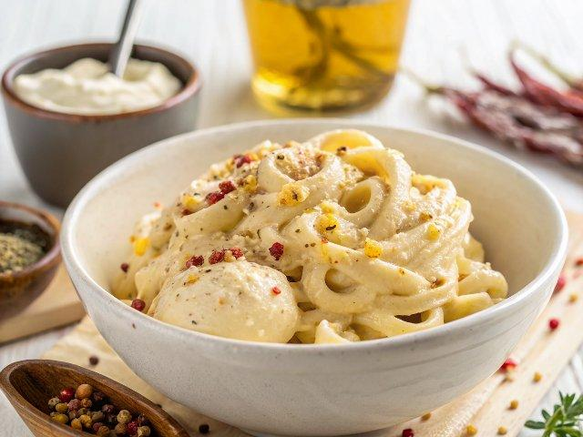

INGREDIENTS  - 1 generous tbsp of extra virgin olive oil  - 1 medium yellow onion, (diced)  - 3 garlic cloves, (minced)  - 1/2 tsp red pepper flakes (optional, for mild heat)  - 3/4 cup (180 mL) vegetable broth or water  - 1 tbsp reduced-sodium tamari (or soy sauce)  - 2 tbsp all-purpose flour*  - 3/4 cup (180 mL) canned “lite” coconut milk or unsweetened oat milk (ideally a creamy full-fat version)**  - 1 tbsp tahini  - 1 tbsp nutritional yeast  - 1/2 tsp smoked paprika  - 1/2 tsp kosher salt + more to taste  - Freshly cracked black pepper to taste  - 1/4 tsp Dijon mustard  - 6 oz (170 g) linguine, fettuccine, or any pasta of choice (including gluten-free)  - Optional garnishes: chopped flat-leaf parsley (or vegan parmesan cheese) | PREP  COOK  1. Bring a large saucepan of salted water to a boil. Cook the pasta until al dente.  2. Meanwhile, heat a deep sauté pan over medium-high heat and add the olive oil. Once the oil is shimmering, add the onions and season with a pinch of kosher salt. Cook for 5-6 minutes, stirring occasionally, until browned around the edges. Add the garlic and red pepper flakes (if using), and stir to combine for 1 minute, until fragrant.  3. While the onions are cooking, pour the vegetable broth (or water) into a measuring cup or bowl and add in the tamari or soy sauce and flour. Whisk to combine until all the flour is dissolved.  4. Pour the vegetable broth-flour mixture into the onion-garlic mixture and whisk to combine, ensuring there are no flour clumps. It should thicken almost immediately. Reduce the heat to medium-low and pour in the coconut milk or oat milk, tahini, nutritional yeast, paprika, 1/2 teaspoon kosher salt, and black pepper to taste. Bring to a simmer and cook for 5 minutes***, or until the sauce is thickened and very creamy, whisking occasionally.  5. Stir in the Dijon mustard, and taste for seasonings, adding more salt as needed. Turn on the pan with the sauce to low heat and add the hot cooked pasta. Use tongs to toss the pasta until it's well coated in the sauce and it's all heated through. Garnish with parsley and/or vegan parm, if using.  PLATING

