MASHED CAULIFLOWER  COOK TIME: 13 min  SOURCE:  #comfort-food #vegetable #healthy | 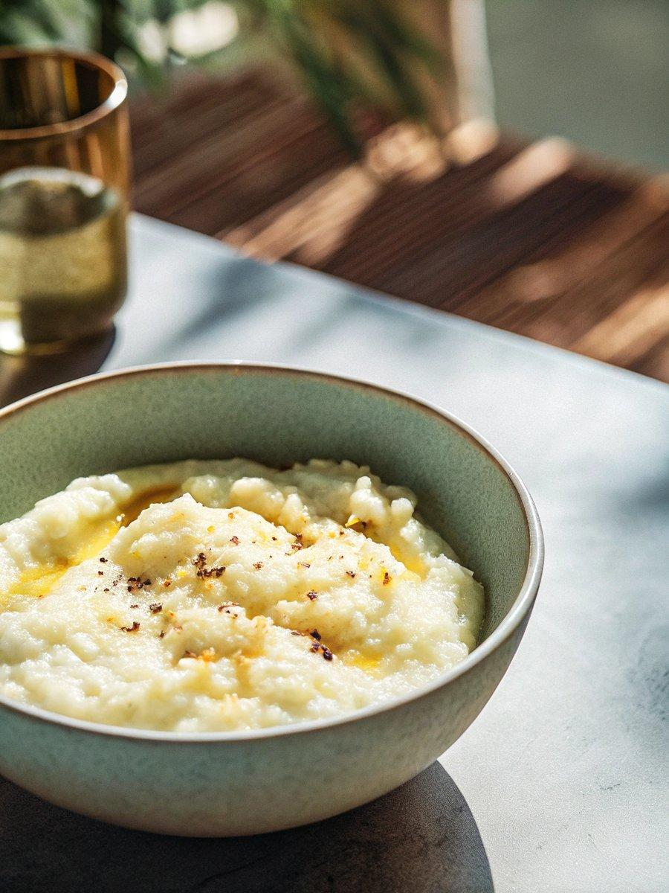

INGREDIENTS  - 1 large or 2 small heads of cauliflower, core removed and cut into florets 1 to 2-inch (5cm) in size (2 lb florets)  - 1 small-to-medium russet potato (about 7 oz), peeled and diced into 1/2-inch (5cm) cubes (optional)  - 4 oz cream cheese, cut into 1-inch (3cm) cubes  - 2 tbsp butter, plus more for serving  - 1/2 tsp garlic powder  - 1/2 tsp onion powder  - 3/4 tsp fine salt, to taste  - Freshly ground black pepper, to taste  - Optional garnishes: Chopped fresh chives, pat of butter and flaky sea salt | PREP  COOK  1. Steam the cauliflower and optional potato: Fill a large pot with 1-inch (3cm) of water. Cover the pot and bring it to an active boil over medium heat. Add the cauliflower and potato (if using), cover, and steam them over medium heat for 11 to 13 minutes, until they are so tender that they fall apart when poked with a fork.  2. Carefully remove the steamer basket from the water and let the veggies cool for 5 minutes or until cool enough to handle.  3. Place the warm potato and cauliflower in the bowl of a food processor with the cream cheese, butter, garlic powder, onion powder, salt, and several twists of black pepper. Process until smooth and creamy, about 2 minutes. (Or mash them in a bowl with a large fork for a chunky consistency.)  4. Taste and blend in another pinch of salt for more overall flavor, or more pepper for contrast. Serve warm with a few pats of melted butter on top, plus a sprinkle of fresh chives and flaky salt, if desired. Leftover mashed cauliflower keep in the refrigerator, covered, for up to 4 days.  PLATING

