MEDITERRANEAN BAKED FISH RECIPE WITH TOMATOES AND CAPERS  COOK TIME: 30 min  SOURCE:  #healthy #baked #seafood | 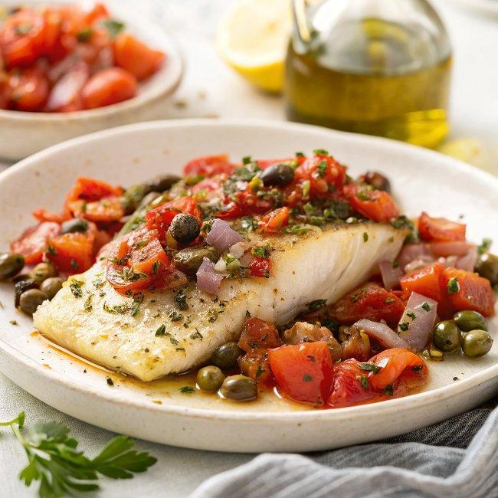

INGREDIENTS  - 1/3 cup Private Reserve Greek extra virgin olive oil  - 1 small red onion, finely chopped  - 2 large tomatoes, diced (3 cups diced tomatoes. Use quality canned tomatoes, if you like)  - 10 garlic cloves, chopped  - 1 1/2 tsp organic ground coriander  - 1 tsp all-natural sweet Spanish paprika  - 1 tsp organic ground cumin  - 1/2 tsp cayenne pepper (optional)  - 1 1/2 tbsp capers  - Salt and pepper  - 1/3 cup golden raisins  - 1 1/2 lb white fish fillet such as cod fillet or halibut fillet (wild, if possible)  - Juice of 1/2 lemon or more to your liking  - Zest of 1 lemon  - Fresh parsley or mint for garnish | PREP  COOK  1. Prepare the tomato and capers sauce. In a medium saucepan, heat extra virgin olive oil over medium-high heat until shimmering but not smoking. Add onions, cook for 3 minutes until it begins to turn gold in color, tossing regularly. Add tomatoes, garlic, spices, pinch of salt (not too much) and pepper, capers, and raisins. Bring to a boil, then turn heat down to medium-low and let simmer for 15 minutes or so.  2. Heat oven to 400°F (200°C).  3. Pat fish dry and season with salt and pepper on both sides.  4. Pour 1/2 of the cooked tomato sauce into the bottom of a 9 1/2″ x 13″ baking dish. Arrange the fish on top. Add lemon juice and lemon zest, then top with the remaining tomato sauce.  5. Bake in 400°F (200°C) heated-oven for 15 to 18 minutes or until fish is cooked through and flakes easily (do not over-cook). Remove from heat and garnish with fresh parsley or mint to your liking.  6. Serve hot with Mediterranean grilled zucchini, Greek potatoes, or Lebanese rice. (See other suggestions for sides or salads up in the post)  PLATING

