CHOW MEIN  COOK TIME: 5 min  SOURCE:  #quick #comfort-food #stir-fry | 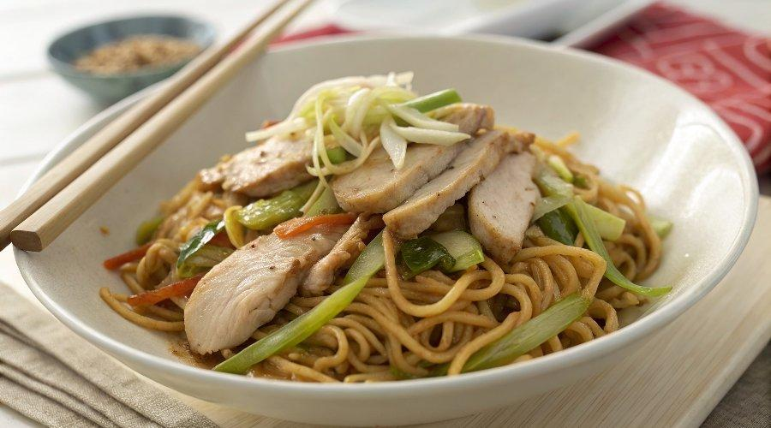

INGREDIENTS  - 200 g /6 oz chicken breast or thigh fillets (, thinly sliced (Note 1 tenderise option)  - 4 cups (960ml) green cabbage (, finely shredded (Note 3)  - 1 1/2 tbsp peanut oil (or other cooking oil)  - 2 cloves garlic (, finely chopped)  - 200 g /6 oz chow mein noodles (Note 2)  - 1 carrot (, julienned)  - 1 1/2 cups bean sprouts  - 3 green onions (, cut into 5 cm/2" pieces)  - 1/4 cup (65 ml) water  - 2 tsp cornflour / cornstarch  - 1 1/2 tbsp soy sauce (, all purpose or light (Note 4)  - 1 1/2 tbsp oyster sauce (sub Hoisin)  - 1 1/2 tbsp Chinese cooking wine (OR Mirin (Note 5)  - 2 tsp sugar (reduce to 1 tsp if using Mirin)  - 1/2 tsp sesame oil  - White pepper (sub black) | PREP  COOK  1. Sauce:  2. Mix together cornflour and soy sauce, then mix in remaining ingredients.  3. Alternative: Use 1/3 cup Chinese All Purpose Stir Fry Sauce, if you have some in stock.  4. Chicken & Noodles  5. Marinate Chicken: Pour 1 tbsp of Sauce over the chicken, mix to coat, set aside to marinate for 10 minutes.  6. Noodles: Prepare the noodles according to the packet instructions (my pack says soak in boiled water for 1 minute), then drain.  7. Cooking:  8. Heat oil in wok or large fry pan over high heat.  9. Add garlic and stir fry for 10 seconds or until it starts to turn golden - don't let it burn!  1  0. Add chicken and stir fry until the surface gets a tinge of browning but inside is still raw - about 1 minute.  1  1. Add the cabbage, carrot, and the white pieces of shallots (i.e. from the base of the stalk). Stir fry for 1 1/2 minutes until the cabbage is mostly wilted.  1  2. Add the noodles, Sauce and water*. Stir fry for 1 minute, tossing constantly.  1  3. Add bean sprouts and remaining shallots/scallions. Toss through for 30 seconds or until the bean sprouts just start to wilt.  1  4. Remove from heat and serve immediately.  PLATING

