AIR FRYER STICKY PORK TACOS WITH PLUM & CHILLI SALSA  COOK TIME: 20 min  SOURCE:  #tacos #pork #air-fryer #spicy #comfort-food | 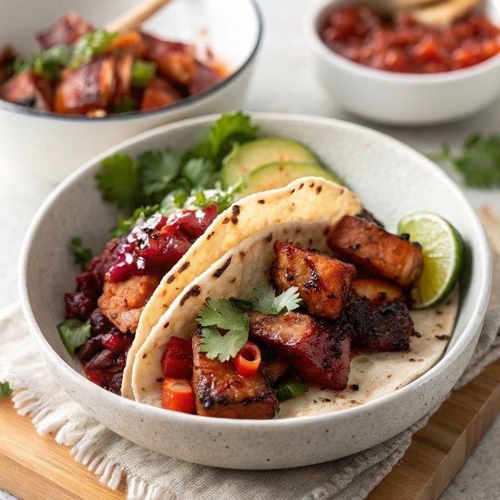

INGREDIENTS  - 480 g pork belly strips cut into 2-3cm (1-inch) chunks  - 1 tbsp dark brown soft sugar  - 2 tsp ground cumin  - 1 tsp Tajín, or use chilli powder  - 1 tsp ground coriander  - 2 garlic cloves grated  - 1 lime juiced  - 12 soft corn tacos warmed, to serve  - soured cream and lime wedges, to serve  - 2 plums stoned and finely chopped into small chunks  - 10 g chives finely sliced  - 10 g coriander roughly chopped, plus extra leaves to serve  - 1 red chilli finely sliced  - 1 lime zested and juiced  - 1-2 tsp caster sugar or to taste | PREP  COOK  1. Put the pork belly in a large bowl, season well, then add the sugar, cumin, Tajín or chilli powder, the ground coriander, garlic and lime juice. Mix well to coat. If you have the time, leave to marinate in the fridge for 1 hr.  2. Heat the air fryer to 190C and cook the pork belly for 15-18 mins, turning halfway, until dark brown and crisp.  3. Meanwhile, make the salsa by combining the plums, chives, coriander, chilli, lime zest and juice and the sugar (depending on the ripeness of the plums, you may need more or less sugar; start with 1 tsp, then taste). Season with salt, mix well and set aside.  4. When the pork is cooked through, fill the warm tacos with soured cream, then the pork, plum salsa and a sprinkling of coriander leaves. Serve with lime wedges on the side to squeeze over.  PLATING

