SINDHI TIDALI DAL RECIPE  COOK TIME: 30 min  SOURCE:  #comfort-food #healthy #protein-rich | 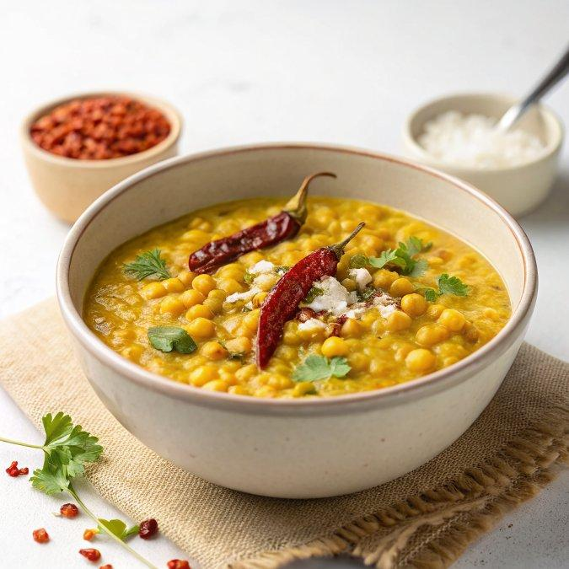

INGREDIENTS  - 1/2 cup Chana dal (Bengal g Dal)  - 1/2 cup Green Moong Dal (Split)  - 1/4 cup White Urad Dal (Split)  - Salt to taste  - 1/2 tsp Turmeric powder (Haldi)  - 1 Green Chilli finely chopped  - 2 Tomatoes finely chopped  - 1-inch (3cm) Ginger finely chopped  - 2 sprig Coriander (Dhania) Leaves finely chopped  - 1 tbsp Ghee  - 1 tsp Cumin seeds (Jeera)  - 1 Asafoetida (hing) a pinch  - 5 cloves Garlic finely chopped  - 1/2 tsp Red Chilli powder | PREP  COOK  1. To begin making the Sindhi Tidali Dal Recipe, wash the chana dal, split green moong dal and urad dal a couple of times and soak them together in a bowl for about 2 hours.  2. In a pressure cooker, add the soaked and drained dals, salt to taste, turmeric powder, green chilli, tomatoes, and ginger.  3. Add about 3 cups (720ml) of water and pressure cook for 4 whistles, and turn off the heat.  4. Allow the pressure to release naturally, then open the lid of the pressure cooker and lightly mash the dals.  5. Heat a tadka pan with ghee on medium heat. Once the ghee is hot, add in the cumin seeds and asafoetida, allow it to sizzle.  6. Once the cumin seeds have crackled add the garlic and continue to cook until it turns into a deep brown colour.  7. Once we have achieved the deep brown colour of the garlic, turn off the heat and add red chilli powder and mix well.  8. Pour this tadka over the cooked tidali dal along with the coriander leaves and mix well. Transfer the Sindhi Tidali Dal into a serving bowl and serve hot.  9. Serve Sindhi Tidali Dal Recipe along with Phulka, Sindhi Karela Jo Bhaji Recipe - Sindhi Style Bitter Gourd Sabzi, and Pickled Onionsfor a simple weekday lunch.  PLATING

