CLASSIC CAKE DONUTS  COOK TIME: 30 min  SOURCE:  #sweet #baked #comfort-food | 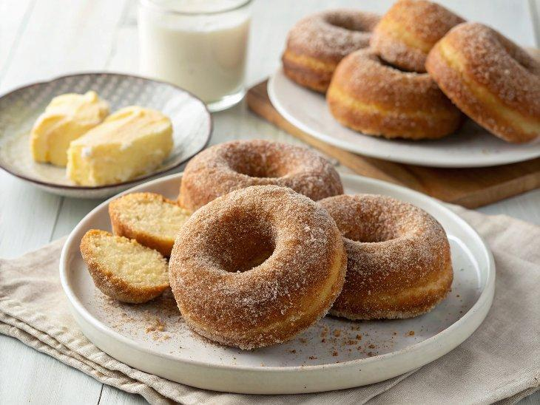

INGREDIENTS  - 6 tbsp unsalted butter (softened)  - 3/4 cup granulated sugar  - 2 large eggs  - 2 tsp pure vanilla extract  - 3 cups (720ml) all-purpose flour (plus more for dusting)  - 1 tbsp baking powder  - 1/2 tsp baking soda  - 3/4 tsp salt  - 1/2 tsp cinnamon  - 2 tbsp sour cream  - 1/4 cup milk  - Canola or vegetable oil for frying (about 48 oz)  - Cinnamon sugar (see below)  - Vanilla glaze  - Chocolate glaze  - Powdered sugar  - 1 1/2 cups granulated sugar  - 1 1/2 tsp cinnamon | PREP  COOK  1. In a large bowl with an electric mixer, cream sugar and butter together. Add in eggs and vanilla and mix on medium speed until combined.  2. In a medium bowl, whisk together the flour, baking powder, baking soda, salt and cinnamon. In a measuring cup, whisk together the sour cream and milk.  3. Add half of the dry ingredients to the butter mixture, followed by all of the milk mixture, then the rest of the dry ingredients, mixing to combine after each addition. Dough should be very soft but still workable.  4. Turn out dough onto a well-floured surface. Dust the dough with flour and knead 2-3 times, just to bring the dough into a ball. Roll to ⅓-inch thickness. Using a donut cutter or a large circle cutter and a small circle cutter, cut the dough into donut shapes, dipping the cutter(s) into flour first to prevent sticking.  5. Re-roll dough scraps as needed to cut all of the dough into donuts.  6. Heat the oil in a large heavy-bottomed pot or Dutch oven until the temperature reaches 375°F (190°C). Do not allow the oil to get much hotter than 375°F (190°C). It's a good idea to keep a fry thermometer in the pot to continually monitor the temperature (see notes).  7. Place a layer of paper towels on top of a half sheet pan. Place a wire cooling rack upside-down on top of the paper towels.  8. Gently ease 2 donuts at a time into the hot oil using a slotted spoon or skimmer. Allow them to cook about 2 minutes on each side; they will brown very quickly. Remove donuts from the oil with a slotted spoon. Allow the excess oil to drip back into the pan.  9. Place donuts immediately on the prepared cooling rack. Flip them over to drain the oil from the other side. Repeat frying process with remaining donuts and donut holes. Donut holes will only need to cook for about 1 minute per side.  1  0. To coat with cinnamon sugar:  1  1. Whisk together the granulated sugar and cinnamon in a shallow bowl.  1  2. Once the donuts come out of the fryer, drain and let cool for 3-4 minutes. While donuts are still warm, coat with the cinnamon sugar. Set on a clean rack to finish cooling.  1  3. To coat with vanilla or chocolate glaze:  1  4. Let donuts cool completely. Whisk together the glaze of your choice. Dip the tops of the donuts in the glaze, then place on a cooling rack set over a sheet pan or a piece of waxed paper to allow excess glaze to drip off.  1  5. To coat with powdered sugar:  1  6. Let donuts cool completely. Place powdered sugar in a shallow bowl. Coat each donut with the powdered sugar.  PLATING

