SCALLION OIL NOODLES (葱油拌面)  COOK TIME: 13 min  SOURCE:  #quick #comfort-food #noodles | 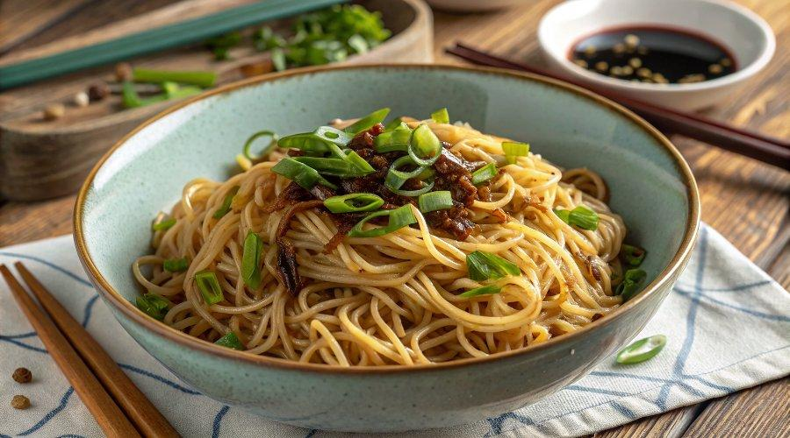

INGREDIENTS  - 6 stalk scallions (aka spring onion, green onion)  - 1/4 cup neutral cooking oil  - 2 tbsp light soy sauce  - 2 tbsp dark soy sauce  - 2 tsp sugar  - 12 oz dried noodles (see note 1) | PREP  COOK  1. Prepare the scallions  2. Wash scallions, then pat dry with paper towels thoroughly. Trim off the ends. Cut them into long sections, then halve each piece lengthways.  3. Infuse the oil  4. Pour oil into a wok/skillet, and add the scallions. Leave to fry over medium-low heat. Once the white part of scallions becomes golden brown, take them out with chopsticks leaving the oil in the wok.  5. Make the sauce  6. Turn off the heat and allow the oil to cool for about a minute. Then, carefully pour in the mixture of light soy sauce, dark soy sauce, and sugar. Mix and let the remaining heat of the oil dissolve the sugar completely (see note 2 & 3).  7. Cook the noodles  8. Bring plenty of water to a full boil. Add noodles and leave to boil until they’re cooked through.  9. Assemble the dish  1  0. Transfer the drained noodles to the wok. Stir and toss to evenly coat each strand with the sauce.  1  1. Portion out the noodles into 4 serving bowls, or put them on a large plate for sharing. Garnish with the fried scallions.  PLATING

