DOLMA (YALANCI DOLMA)  COOK TIME: 30 min  SOURCE:  #stuffed #healthy #comfort-food | 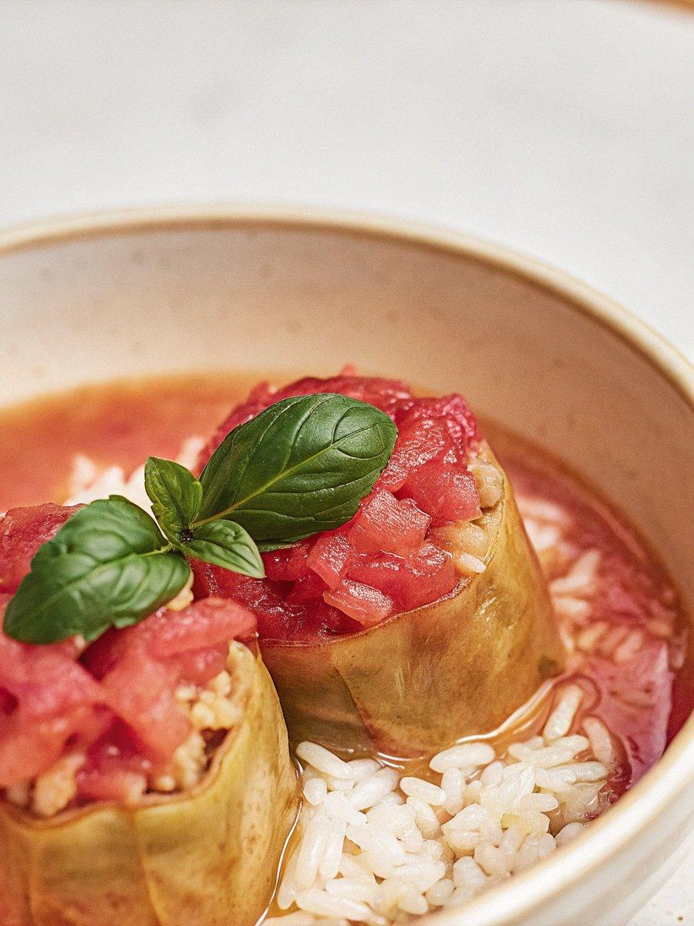

INGREDIENTS  - 250 g long-grain white rice  - 6 tbsp extra virgin olive oil  - 1 large onion very finely diced  - 4 tbsp tomato purée  - 25 g fresh mint leaves finely chopped  - 30 g fresh flat leaf parsley finely chopped  - 400 g can chopped tomatoes  - 1 tbsp pomegranate molasses  - 100 ml fresh lemon juice around 3 lemons  - 2 tbsp dried mint  - 1 x 420 g vacuum-packed vine leaves | PREP  COOK  1. Wash the rice in a sieve under cold running water until the water runs clear, then allow to drain fully in a sieve.  2. Meanwhile, heat 3 tbsp of the olive oil over a low heat and add the onions. Soften for 15-20 mins until translucent and caramelised. Add 3 tbsp of the tomato purée to the onions, gently breaking it down into the oily juices, around 2 mins. Stir in the rice, coating the grains fully in the tomato and onion mix, then remove the pan from the heat and transfer the contents to a large dish, ours was 22cm (9-inch). Add the fresh mint and parsley to the dish, along with the chopped tomatoes, pomegranate molasses, lemon juice, dried mint, 1½ tsp fine sea salt and ¾ tsp freshly ground black pepper. Stir to combine, then allow to cool to room temperature. Chill for 1 hr to allow the flavours to come together.  3. While the mixture is chilling, prepare the vine leaves. Put them in the widest saucepan you have, then wash them thoroughly in cold water 3-4 times. Fill the pan up with cold water, place it on the hob over a medium heat, bring to the boil for 10 mins. Switch off the heat, then cover the pan and leave the leaves to sit in the boiling water for another 10 mins. Carefully drain the hot water from the pan, then fill the pan up with cold water and drain a couple more times to rid the leaves of any brine. Fill the pan up with cold water again so that the leaves are covered – this will make it easier to remove the leaves from the pan without tearing them. Reserve 4-5 large vine leaves for later, then use the rest of them to make the dolma.  4. Dissolve the remaining 1 tbsp tomato purée in a heatproof jug with 200ml boiling water, then top up with 300ml (1.2 cups) cold water and stir well.  5. Lay one vine leaf on a large plate with the widest side of the leaf facing you and the point furthest away. If the leaves still have a stalk attached to them, cut them off. Cover with a heaped teaspoon of the mixture along the widest point, leaving just over 1 cm (½ inch) of space at the sides and along the edge closest to you. Fold this closest edge over the filling, fold in the sides, then roll the dolma away from you until you have a tightly packed cigar-shaped roll.  6. Add a couple of the reserved leaves at the bottom of a large pan, then lay the rolled dolma (with the pointy end of the leaf facing the underside of the pan to prevent the dolma unravelling while cooking) at the bottom of the pan and repeat with the remaining leaves and filling. Arrange the dolma snugly, but ensure to leave enough space for them to expand while cooking, in layers.  7. Drizzle the remaining 3 tbsp olive oil into the pan, then cover the dolma with the remaining reserved leaves. Add a couple of heatproof plates on top of the leaves to lightly weigh down the contents of the pan, then pour in just enough of the tomato liquid so that it comes just over the rim of the plates by 2 cm (¾ inch). Feel free to top up with a little more water if the quantity of liquid is not quite enough, or hold back if it is too much. Set the pan over a medium heat, bring to the boil, then reduce the heat as low as possible. Put the lid on the pan and cook for around 20-25 mins until most of the water has reduced, but you can still see a small amount bubbling away. Remove the pan from the heat and allow to cool for at least 2 hrs (preferably a few more) before serving.  PLATING

