RICOTTA HERB BREAD ROLLS  COOK TIME: 30 min  SOURCE:  #comfort-food #homemade #baking | 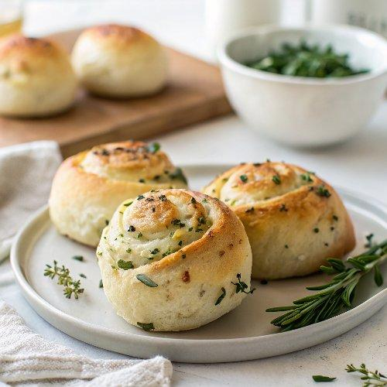

INGREDIENTS  - 1/4 cup warm whole milk (100 to 110°F)  - 1 cup (246 g) part skim ricotta cheese, at room temperature  - 2 tbsp olive oil, divided, plus more for coating  - 2 whole eggs, at room temperature  - 1 tsp granulated sugar  - 1 1/2 tsp fine sea salt  - 1 tbsp minced fresh rosemary  - 1 tbsp minced fresh thyme  - 2 1/4 tsp (1 packet) instant yeast  - 3 1/2 to 4 cup (960ml)s (445 to 508 g) all-purpose flour  - Flake sea salt, for sprinkling | PREP  COOK  1. In the bowl of a stand mixer, combine the milk, cheese, 1 tablespoon of the oil, eggs, sugar, salt, herbs, and yeast. Add 2 cups (480ml) of the flour and stir with a wooden spoon until the dough forms a rough, shaggy mass. Attach the dough hook to the mixer, turn to medium-low speed, and gradually add 1 1/2 cups more flour, kneading until a mass of dough begins to forms. Continue kneading on medium-high speed for 4 to 5 minutes until a soft, smooth ball of dough is formed, adding more flour only as needed. The dough should feel elastic and slightly sticky to the touch. Avoid adding too much additional flour.  2. Lightly coat large clean bowl with olive oil and place the dough in the bowl. Cover the bowl lightly with plastic wrap. Let rise for about 1 1/2 hours at room temperature or until the dough is big, puffy, and about doubled in size.  3. Spray a 13×9-inch (23cm) baking pan with cooking spray. Gently deflate the dough. Use a bench scraper, knife, or pizza wheel to divide the dough into 15 equal pieces. Shape each piece into a ball and place in the prepared pan. Brush with the remaining 1 tablespoon of olive oil and sprinkle generously with flake sea salt. Lightly cover the dough with plastic wrap and let the rolls rise for 45 minutes, or until about doubled in size.  4. MAKE AHEAD: At this point the shaped rolls can be covered and allowed to rise in the fridge overnight. Bring to room temperature before baking.  5. Preheat the oven to 375°F (190°C).  6. Bake the rolls for 25 minutes, or until golden brown. Serve warm. Store leftovers in a plastic bag for up to 3 days.  PLATING

