KOREAN PICKLED PERILLA LEAVES (KKAENNIP JANGAJJI)  COOK TIME: 10 min  SOURCE:  #quick #korean #pickled | 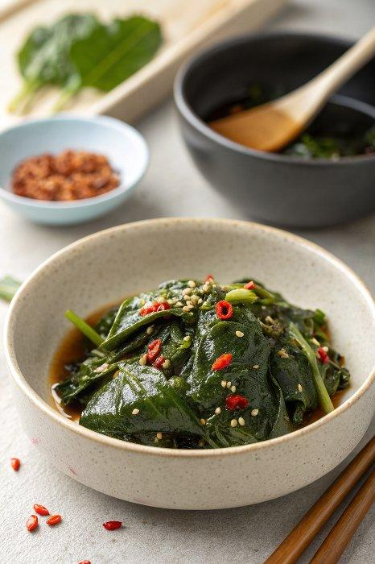

INGREDIENTS  - 32 leaves perilla (98 g / 3.5 oz)  - 10 Tbsp soy sauce (, regular (I use naturally brewed kikkoman soy sauce.)  - 1 tsp Korean chili flakes (gochugaru)  - 1 tsp minced garlic  - 2 Tbsp brown sugar  - 2 Tbsp spring onion (, finely chopped)  - 2 Tbsp green chilies (or red chilies, (optional), finely chopped) | PREP  COOK  1. Rinse the perilla leaves in cold running water and drain/air dry them while left in the colander.  2. While waiting for the perilla leaves to dry, prepare the seasoning sauce.  3. Place the perilla leaves in stacks in a large (glass) container (with a lid). Spread (about 1 Tbsp worth of) seasoning sauce on top of the perilla leaf. Repeat this process for every 3 leaves for the rest of leaves. As it is already stacked, you will have to lift the leaves at every third interval with one hand while the other hand is spreading the sauce. You don’t need to spread the sauce on every leaf. If you have any sauce leftover, pour it onto the stacked leaves. If you run out of sauce, tip the container and scoop out the sauce from the bottom corner of the container and spread it over the perilla leaves.  4. Close the lid and move the container to the fridge. You can start eating this from the next day. Serve it with a hot bowl of rice. (It can be stored in the fridge for at least one week. Though traditionally this dish was made during the summer months when many perilla leaves are available and consumed through the summer to winter.)  PLATING

