CHOCOLATE CHIP COOKIE DOUGH CHEESECAKE BAR  COOK TIME: 40 min  SOURCE:  #sweet #baked #chocolate | 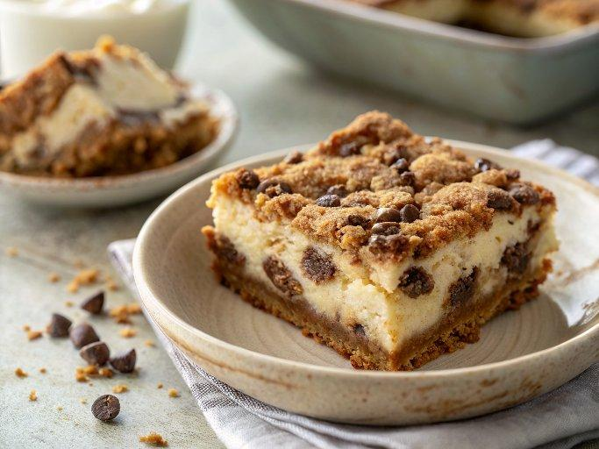

INGREDIENTS  - 1 1/2 cups graham cracker crumbs  - 5 tbsp unsalted butter (melted)  - 5 tbsp unsalted butter (room temperature)  - 1/3 cup light brown sugar (packed )  - 3 tbsp granulated sugar  - 1/4 tsp salt  - 1 tsp pure vanilla extract  - 3/4 cup flour  - 1 cup (240ml) chocolate chips  - 10 oz. (280 g) cream cheese (room temperature)  - 1/4 cup sugar  - 1 large egg (room temperature)  - 1 tsp pure vanilla extract | PREP  COOK  1. Preheat the oven to 325Â°F (162Â°C). Line an 8-inch (20 cm) square baking pan with parchment paper or foil, allowing a little overhang, and spray with nonstick cooking spray. Set aside.  2. Mix the melted butter and graham cracker crumbs until thoroughly combined. Press the mixture into the bottom of the prepared pan. Bake in the preheated oven for 6 minutes. Remove the pan and place it on a cooling rack. Do not turn your oven off.  3. While the crust is cooling, prepare the chocolate chip cookie dough. In the bowl of a stand mixer fitted with the paddle attachment or in a large bowl with an electric mixer, beat the butter, brown sugar, granulated sugar, salt, and vanilla until smooth and thoroughly combined, about 1 minute. Mix in the flour on low speed until just incorporated. Then, mix in the chocolate chips. Set aside.  4. In the bowl of a stand mixer fitted with the paddle attachment or in a large bowl with an electric mixer, cream together the cream cheese and sugar until smooth. Mix in the egg and vanilla on low speed, just until incorporated. Pour the cheesecake batter into the prepared crust.  5. Using your hands, form clumps of dough. Flatten the clumps in your palms to spread them out a bit. Distribute the cookie dough evenly over the top of the cheesecake batter, ensuring most of the cheesecake is covered. Use all of the dough.  6. Bake for about 30 minutes, or until the top feels dry and firm (the cookie dough), and the entire pan looks set when gently shaken. Move the bars to a cooling rack and let them cool completely.  7. Lift the bars out by the overhang, slice into your desired size, and store in the refrigerator. Serve cold or at room temperature.  PLATING

