MANDARIN ORANGE SALAD WITH CHICKEN AND LEMON GINGER DRESSING  COOK TIME: 10 min  SOURCE:  #healthy #light #refreshing | 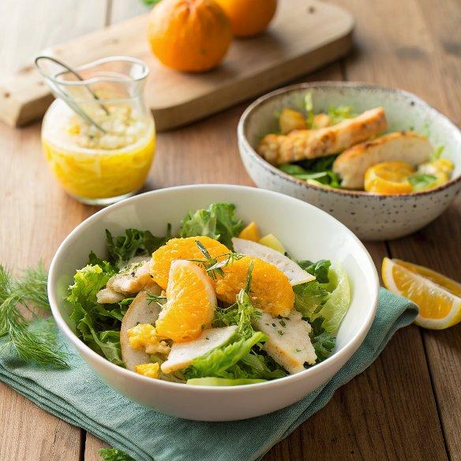

INGREDIENTS  - 1/4 cup olive oil  - 1/4 cup canola oil  - 1 tsp lemon zest  - 3 1/2 Tbsp fresh lemon juice  - 2 Tbsp honey  - 2 Tbsp peeled and grated ginger  - 1 clove garlic  - 1 tsp dijon mustard ((Emeril's is the only way to go))  - 1/4 - 1/2 tsp salt (, to taste)  - 12 wonton wrappers (, sliced into 1/2-inch thick strips)  - Vegetable oil (, for frying)  - Cinnamon  - 1 lb boneless skinless chicken breast (, grilled and sliced)  - 1 cup (240ml) sliced almonds (, toasted)  - 10 oz baby spinach  - 2 cups (480ml) snow peas (, sliced into halves)  - 1 1/2 cups matchstick carrots  - 1 red bell pepper (, seeded and diced)  - 1 1/2 (15 oz) cans mandarin oranges (no sugar added), drained well*  - 1/2 cup cilantro (, stems removed)  - Black and white sesame seeds (, for garnish (optional)) | PREP  COOK  1. For the dressing:  2. For the wonton strips:  3. For the salad:  PLATING

