TRIPLE BERRY KAHLUA CRISP WITH DOUBLE THE CRUMBLE.  COOK TIME: 25 min  SOURCE:  #berry #crisp #comfort-food #easy | 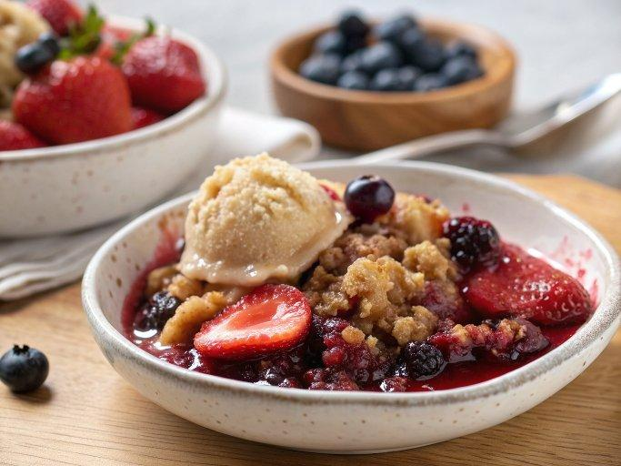

INGREDIENTS  - 2 cups (480ml) fresh strawberries (quartered)  - 2 cups (480ml) fresh blueberries  - 1 1/2 cups fresh blackberries  - 2-4 tbsp kahlua (depending on your taste)  - 1 tsp vanilla extract  - 1/4 cup brown sugar  - 1/2 a lemon (zested)  - 2 cups (480ml) old fashioned rolled oats (use gluten free if needed)  - 6 tbsp flour (use gluten free if needed)  - 1/2 cup brown sugar  - 1 tsp baking soda  - 1/4 tsp cinnamon  - 1/4 tsp salt  - 1 1/2 sticks unsalted butter (softened)  - vanilla bean ice cream (for serving) | PREP  COOK  1. Preheat the oven to 375°F (190°C).  2. In a 12-inch (30cm) cast iron skillet or 9x13-inch (23x33cm) baking dish toss together the strawberries, blueberries and blackberries. Add the Kahlua, vanilla extract, brown sugar (1/4 cup) and lemon zest. Toss well to combine.  3. In a medium size bowl add the oats, flour, brown sugar (1/2 cup), baking soda, cinnamon and salt. Add the softened butter and use your fingers to crumble it into the oats mixture until everything is moist and the butter is evenly distributed. Sprinkle the crisp over the berries. Bake for 25-30 minutes, until crisp is golden brown and the fruit is bubbling up and smells amazing.  4. Serve immediately with a large scoop of ice cream and a drizzle of the sauce that settles in the skillet. DEVOUR!  PLATING

