VEGAN RED VELVET CUPCAKES  COOK TIME: 25 min  SOURCE:  #sweet #baking #comfort-food | 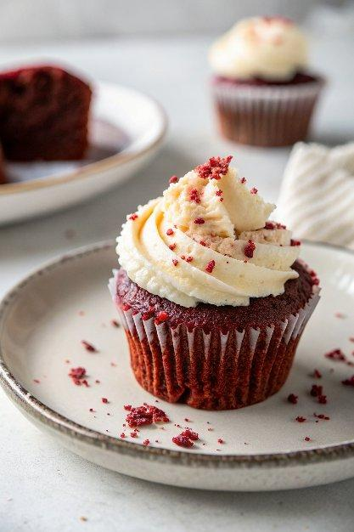

INGREDIENTS  - 1 cup (240ml) soy milk  - 2 tsp white distilled vinegar  - 1 1/3 cups all purpose flour  - 1/4 cup cornstarch  - 2 tbsp natural cocoa powder  - 1 cup (240ml) granulated sugar  - 1 tbsp baking powder  - 1/4 tsp salt  - 1/2 cup canola oil  - 1/4 cup applesauce  - 2 tsp pure vanilla extract  - 1-3 tbsp vegan red food coloring  - 1/2 cup vegan butter, softened  - 3 cups (720ml) powdered sugar  - 1 tsp apple cider vinegar  - 1/2 tsp pure vanilla extract  - 1-2 tbsp soy milk, as needed | PREP  COOK  1. Preheat the oven to 350°F (175°C) and line a 12-cup muffin pan with paper liners.  2. In a measuring cup, combine the soy milk and vinegar. Let sit a few minutes until it curdles (this is your vegan buttermilk).  3. In a large mixing bowl, whisk together the flour, cornstarch, cocoa powder, sugar, baking powder and salt until well combined.  4. To the bowl with the dry ingredients, add the oil, applesauce, vanilla, red food coloring and milk/vinegar mixture. Stir well with a large spoon or spatula until smooth and well combined. I used 2 tablespoons of red food coloring.  5. Fill the liners 3/4 full. Bake for 20-25 minutes, or until a toothpick inserted comes out clean. Cool completely before frosting.  6. Make the Frosting: Using a hand mixer, beat the softened vegan butter for 1-2 minutes until creamy, then add the powdered sugar, apple cider vinegar and vanilla and beat everything together until smooth and creamy, adding a tablespoon of non-dairy milk at a time as needed. If you add too much milk and it gets runny, you will need to add more powdered sugar.  7. Once the cupcakes are cooled completely, frost as desired and serve. If you are going to pipe a lot of frosting on each cupcake, you may want to double the frosting.  PLATING

