BROCCOLI CHEESE SOUP  COOK TIME: 50 min  SOURCE:  #comfort-food #quick #healthy | 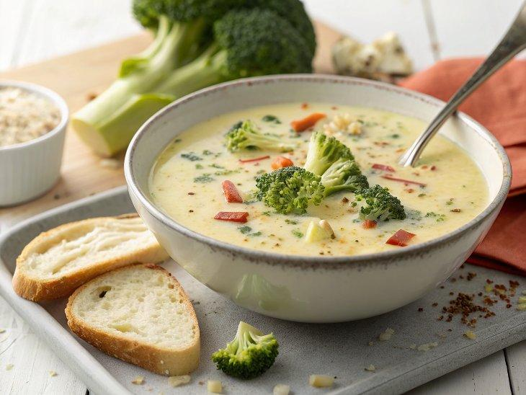

INGREDIENTS  - 3 tbsp unsalted butter  - 2 medium yellow onions, coarsely chopped  - 6 garlic cloves, smashed and peeled  - 1/2 tsp red pepper flakes (reduce or omit if sensitive to spice)  - 1 1/4 tsp fine sea salt, divided, to taste  - Freshly ground black pepper, to taste  - 2 lb broccoli with stalks (3 large or 4 medium)  - 1 large (about 12 oz) russet potato, peeled and cut into 1 to 2-inch (5cm) chunks  - 6 cups (1440ml) water  - 4 to 8 oz grated sharp cheddar cheese, depending on your mood  - Thinly sliced chives or green onions, for garnish (optional) | PREP  COOK  1. Melt the butter in a large Dutch oven or soup pot over medium-low heat. Add the onion, garlic, red pepper flakes, ¼ teaspoon of the salt, and about 10 twists of black pepper.  2. Stir to combine, then cover the pot and cook, stirring occasionally, until the onions have softened and are just starting to turn golden, about 8 to 10 minutes.  3. Meanwhile, slice off and discard the rough bottom ends of broccoli stalks. Use a vegetable peeler to peel off the tough outer skin on the stalks, then discard those bits. Slice the stalks off and cut them into pieces about 1 to 2-inch (5cm) big. Set aside.  4. Working with the broccoli tops now, cut as closely to the base of the florets as you can. Slice any remaining stalks into chunks to match to the rest. Reserve the broccoli florets—we’ll use them in a bit.  5. Add the chunks of broccoli stalk and potato to the pot and stir. Pour in 6 cups (1440ml) water and the remaining 1 teaspoon salt. Raise the heat to high and bring the mixture to a boil, then reduce the heat to medium-low and cover the pot.  6. Simmer until the broccoli stalks and potatoes are tender throughout and easily split apart when pierced with a fork, about 20-25 minutes. Meanwhile, chop the reserved florets into small pieces (I chop them all in one direction, then turn the cutting board and chop again).  7. Once the potato and stalks are tender, add half of the florets to pot, stir, cover, and cook until they’re bright green, about 3 to 5 minutes. Remove the pot from the heat. Working in a couple of batches (never fill your blender past the maximum fill line or it could explode!), carefully transfer several cups of the mixture—both the liquid and solids—to your stand blender. Blend until completely smooth, then transfer the mixture to a heat-proof vessel temporarily as you blend the rest. Alternatively, use an immersion blender (it just won’t be as lusciously creamy). Return the purée to the pot.  8. Return the pot to medium heat and add the remaining florets. Cover the pot and cook until they’re bright green and easily pierced through by a fork, another 4 to 7 minutes. Add almost all 4 ounces of the grated cheddar cheese (reserve a small handful for garnish) and stir until smooth. Carefully taste (it’s hot) and stir in more cheese if you’d like more indulgent flavor/creamy texture, more salt for more overall flavor, and/or more black pepper for kick.  9. Divide the soup into bowls and top with a sprinkle of cheese, plus some thinly sliced chives and/or red pepper flakes, if desired. Leftover soup keeps well in the refrigerator for up to 4 days (though the color darkens a bit with time). I haven’t tried freezing this soup but suspect it will work fine—please let us know in the comments if you do.  PLATING

