VEGAN NO-BAKE CHEESECAKE  COOK TIME: 1h 15m  SOURCE:  #no-bake #healthy #dessert | 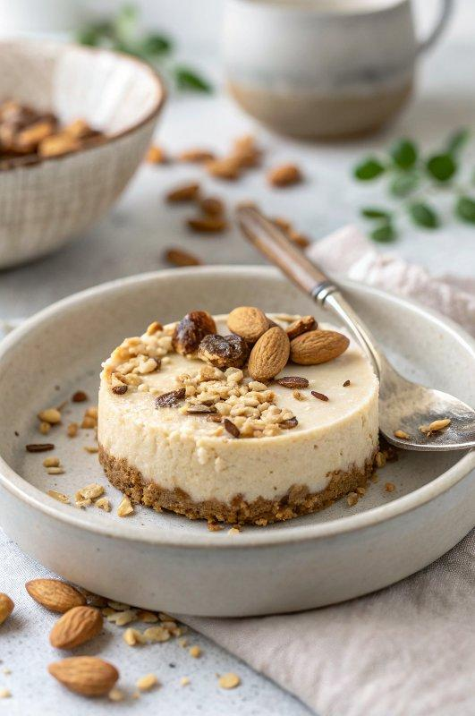

INGREDIENTS  - 1/2 cup nuts or seeds of choice (see notes)  - 1 cup (240ml) oats (gluten-free if needed (see notes)  - 20 small dates (pitted (see notes)  - 1 tsp vanilla extract  - 1/2 tbsp coconut oil  - 2/3 cup cashews (soaked (see notes)  - 1 cup (240ml) canned coconut milk (see notes)  - 3 tbsp maple syrup (or a different liquid sweetener)  - 1 1/2 tsp agar powder (not flakes! + 1/4 cup water (see notes)  - 1 tsp vanilla extract  - 2 tbsp lemon juice (or lime juice)  - 3 tsp pink dragon fruit powder (optional - see notes) | PREP  COOK  1. It's best to measure the ingredients in grams on a kitchen scale for this recipe. If you have a larger springform (e.g. 9-inches), I recommend doubling the whole recipe.  2. Soak cashews in hot water for an hour (or boil them for 15 minutes). You can also soak them overnight in cold water.  3. Process all crust ingredients in a food processor until the mixture holds together when you press it between your fingers. Press the dough into the bottom of a greased 6-inch (15cm) cheesecake pan or springform and about 2-inch (5cm)es (5 cm) up the sides. Put the pan in the refrigerator until you finish making the cream. Read the recipe notes below if you prefer a baked crust.  4. Blend all cream ingredients, except the agar powder (and water), in a blender (or powerful food processor) on high speed for about 1-2 minutes or until the cream is completely smooth.  5. In a small saucepan, add the agar powder and 1/4 cup of water. Bring the mixture to a boil and let simmer for 2 minutes, stirring frequently. Immediately add the mixture to the blender and blend again for about 10-20 seconds.  6. Quickly pour the cream into the cheesecake pan (or springform). Refrigerate for a few hours (or overnight) until set. To speed up the process, you can also put the pan into the freezer for about 45-60 minutes or until set. The cheesecake tastes best when it's served cold but not frozen. Store cheesecake leftovers in the fridge for up to 5 days.  PLATING

