VIETNAMESE CARAMELISED PORK BOWLS  COOK TIME: 10 min  SOURCE:  #comfort-food #quick #rice | 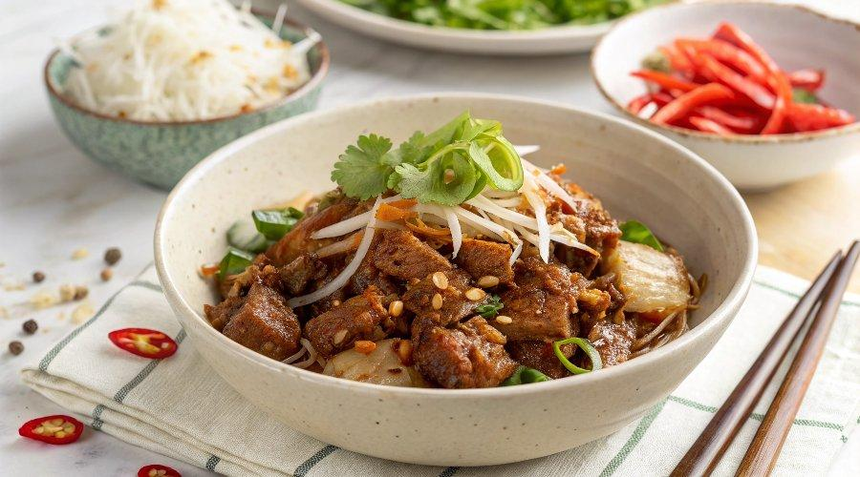

INGREDIENTS  - 1 1/2 tbsp cooking oil (I use peanut oil)  - 1/2 onion (, finely diced (brown, white or yellow) (~1/2 cup)  - 2 tsp ginger (, grated or minced)  - 2 garlic cloves (, minced (2 tsp paste)  - 1 birds eye or Thai chili (, deseeded and finely chopped (can omit, Note 1)  - 500 g / 1 lb pork mince (ground pork) (Note 2)  - 5 tbsp (tightly packed brown sugar (don't skimp, else won't caramelise)  - 2 tbsp fish sauce  - 1 green onion stem (, finely sliced)  - Jasmine rice (or other rice for serving)  - Sliced red chilli, tomato, cucumber (optional) | PREP  COOK  1. Heat the oil in a large skillet over high heat.  2. Sauté - Add the onion, ginger, garlic and chili and cook for 2 minutes.  3. Cook pork - Add the pork mince and cook for 2 minutes or so until white all over, breaking up the meat with a wooden spoon.  4. Add sauce & caramelise - Add the sugar and fish sauce. Stir, then leave it to cook without touching until all the juices cook out and the pork starts caramelised - about 2 minutes. Then stir it and leave it again, without stirring, for around 30 seconds to get more caramelisation. Repeat twice more until caramelised to your taste.  5. Serve over jasmine or other rice, or vermicelli noodles, garnished with sliced green onion. For a low carb, low cal option, try Cauliflower Rice! I like to have chunks of plain cucumber and carrots on the side which is a classic way of making Vietnamese bowls.  PLATING

