NO-BAKE STRAWBERRY BLUEBERRY TRIFLE  COOK TIME: 30 min  SOURCE:  #no-bake #fruit #quick #light #summer | 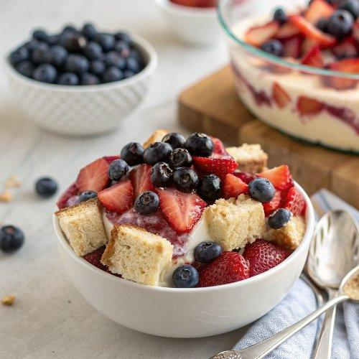

INGREDIENTS  - 17 oz angel food cake (cut into 1" cubes (I used 1 1/2 blocks)  - 1 lb strawberries (hulled and sliced)  - 1 lb blueberries  - 1/4 cup water  - 2 Tbsp sugar  - 2 Tbsp lemon juice (from 1/2 medium lemon)  - 16 oz cream cheese (softened at room temp)  - 3/4 cup granulated sugar  - 2 cups (480ml) heavy whipping cream  - 1/2 tsp vanilla extract  - 4 or 5 qt trifle dish (I found mine at TJ max, or make it in a 9 x13 casserole dish.) | PREP  COOK  1. How to Make Lemon Syrup:  2. In a measuring cup, combine 1/4 cup water, 2 Tbsp sugar and 2 Tbsp lemon juice and stir until sugar is dissolved. Set aside until needed.  3. How to Make the Trifle Cream:  4. Beat together 1 lb cream cheese and 3/4 cup sugar (with the whisk attachment) on medium speed until creamy and smooth, scraping the bowl a couple times. With mixer on, pour in 2 cups (480ml) heavy cream then turn mixer to medium/high and continue beating until until whipped and fluffy. Add 1/2 tsp vanilla and beat until incorporated.  5. Assembling the Berry Trifle:  6. Place 1/3 of your sliced angel food cake into the bottom of your trifle dish and brush with 1/3 of your syrup. Add 1/3 of your cream and loosely spread it over cake pieces. Add 1/2 of the sliced strawberries. Repeat with remaining ingredients (adding 1/2 of the blueberries for the second fruit layer). Frost the top with last 1/3 of cream and decorate with remaining fruit. (Visit my blog for a closer look at the order of the cake layers).  PLATING

