HONEY TERIYAKI DRUMSTICKS  COOK TIME: 45 min  SOURCE:  #quick #comfort-food #grilled | 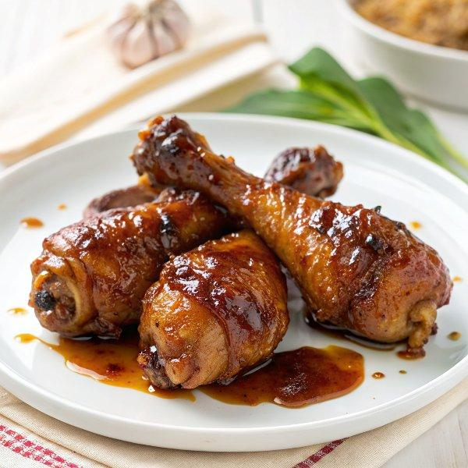

INGREDIENTS  - 1/4 cup low sodium soy sauce (or gluten free)  - 3 tbsp rice wine  - 2 tbsp honey  - 2 cloves garlic (minced)  - 1 tsp fresh grated ginger  - 1 tsp sriracha (optional)  - 8 drumsticks (28 oz, skin removed)  - 1 tbsp sesame seeds  - chopped scallions | PREP  COOK  1. Skillet Directions:  2. Combine soy sauce, rice wine, honey, garlic, ginger and sriracha in a skillet and cook medium-low, stirring for about 2 minutes.  3. Add the chicken and cook 5 minutes, covered. Turn chicken, cover and cook 20 minutes over medium-low. Turn again, cover and cook 15 minutes, until the chicken is very tender. Remove the cover, if the sauce isn't thick simmer uncovered until sauce thickens, about 2 minutes.  4. Finish with scallions and sesame seeds.  5. Instant Pot Directions:  6. Use saute button, when hot add soy sauce, rice wine, honey, garlic, ginger and sriracha and cook 2 minutes, stirring. Add the chicken, cover and lock the lid. Cook on high pressure 15 to 20 minutes until the chicken is tender.  7. When pressure releases, finish with scallions and sesame seeds.  PLATING

