BANANA CHOCOLATE CHIP MUFFINS  COOK TIME: 25 min  SOURCE:  #quick #comfort-food #baking | 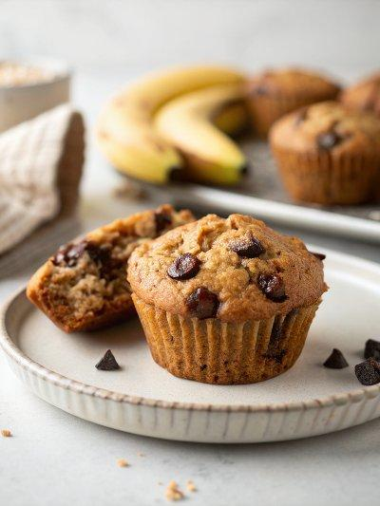

INGREDIENTS  - 1 2/3 cups all-purpose flour, (spooned into measuring cup and leveled-off)  - 1 tsp baking powder  - 1 tsp baking soda  - 1/2 tsp salt  - 1/2 cup (1 stick) unsalted butter, at room temperature  - 3/4 cup plus 2 tbsp sugar  - 2 large eggs  - 1 cup (240ml) mashed bananas, (from 2 to 3 overripe bananas)  - 1 tsp vanilla extract  - 1/3 cup sour cream or plain Greek yogurt (low-fat is fine)  - Heaping 3/4 cup semi-sweet chocolate chips | PREP  COOK  1. Preheat the oven to 350°F (175°C) and set an oven rack in the middle position. Line a 12-cup muffin tin with paper liners.  2. In a medium bowl, whisk together the flour, baking powder, baking soda, and salt. Set aside.  3. In the bowl of an electric mixer, beat the butter and sugar on medium-high speed until fluffy, about 2 minutes. Scrape down the sides of the bowl with a rubber spatula. At medium speed, add the eggs one at a time, beating until fully incorporated between additions. Add the mashed bananas, vanilla, and sour cream (or Greek yogurt) and beat until blended (the batter will look a bit curdled; that's okay). Add the dry ingredients and mix on low speed until well blended. Set aside 3 tablespoons of the chocolate chips (you'll sprinkle those over the top of the muffins); on low speed, mix the remaining chips evenly into the batter.  4. Spoon the batter into the prepared muffin tin (the cups will be very full) and sprinkle evenly with the reserved chocolate chips. Bake the muffins until the tops are golden and domed, 23 to 25 minutes. Let the muffins cool in the pan for 10 minutes, then turn them out onto a rack and let cool for at least 10 minutes before serving. The muffins are best fresh out of the oven but will keep for up to 4 days stored in a sealed container or resealable plastic bag, in a single layer (to prevent the muffins from getting soggy, line the top and bottom of the container or bag with a single layer of paper towels).  PLATING

