MY MICROWAVE CHILLI CON CARNE  COOK TIME: 45 min  SOURCE:  #quick #comfort-food #hearty | 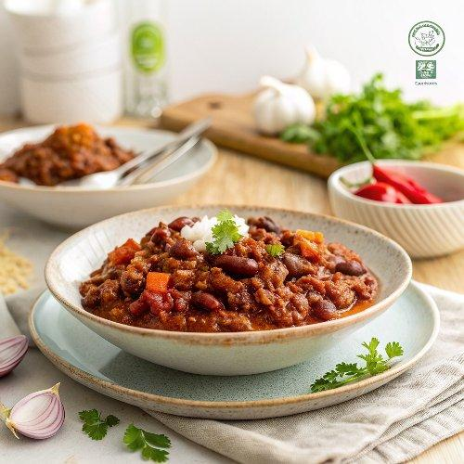

INGREDIENTS  - 250 g minced beef  - 1 heaped tsp ground cumin  - olive oil  - 1 beef stock cube  - 1 onion  - 2 cloves of garlic  - 2 sticks of celery  - 1-2 mixed chillies  - 400 g butternut squash  - red wine vinegar  - 2 tbsp tomato purée  - 1 x 400 g tin of chopped tomatoes  - 1 x 400 g tin of kidney beans  - 1 mug of long grain rice (300 g) | PREP  COOK  1. Put the beef, cumin, 2 tablespoons of olive oil, a pinch of sea salt and a big pinch of black pepper into a microwave-proof dish. Crumble in the stock cube and scrunch together with clean hands. Microwave for 10 minutes on high (800W) or until the meat is browned, breaking it up with a wooden spoon halfway.  2. Meanwhile, peel the onion and garlic, then very finely chop with the celery. Deseed and finely chop the chillies. Put a handful of the chopped veg into a small bowl for the salsa, then slice off a thin piece of squash, finely chop and add to the bowl. Stir in 1 teaspoon of red wine vinegar and a pinch of salt, and leave to pickle.  3. When the time’s up on the beef, stir in the remaining chopped veg. Slice the reserved squash into 4 large pieces (there’s no need to peel it) and lightly score the skin. Place the squash on top, then return to the microwave and cook for another 15 minutes on a high heat (800W).  4. Add the tomato purée and tomatoes to the dish, drain and tip in most of the beans (putting a small handful aside for later). Gently mash with a potato masher, until some of the beans are squashed into the sauce. Return to the microwave and cook for a final 20 minutes on medium-high (600-700W), or until the squash is soft. Carefully lift the dish out of the microwave and place on a heatproof surface. Use your potato masher to mash the squash, if you like, then carefully taste the chilli (it will be hot) and season to perfection. Cover to keep warm while you crack on with the rice.  5. Place the rice in a 2-litre microwave-proof dish or bowl with 2 mugs of water (600ml) and a pinch of sea salt. Cover the bowl with a lid or a side plate, sprinkle the reserved beans on top, then cook in the microwave on a high heat (800W) for 10 to 14 minutes (depending on the strength of your microwave), carefully removing the beans halfway.  6. Fluff up the rice and divide between plates, spoon over the chilli, then sprinkle with the popped beans and salsa, and serve.  PLATING

