MUSHROOM PIE  COOK TIME: 1h 10m  SOURCE:  #comfort-food #baked #hearty | 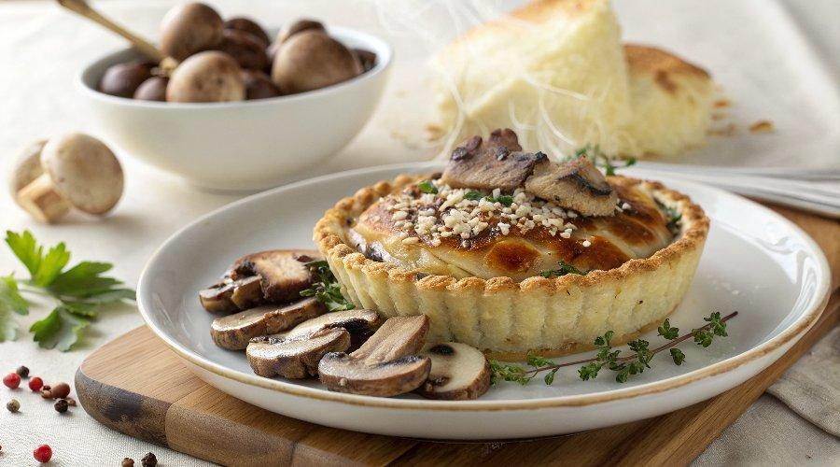

INGREDIENTS  - 200 g unsalted butter  - 400 g plain flour  - 1 tbsp thyme leaves  - 2 eggs  - 130 ml cold whole milk plus a splash  - 25 g dried mixed mushrooms  - 750 g chestnut mushrooms  - 500 g portobello mushrooms  - 200 g button mushrooms  - 3 tbsp olive oil plus a drizzle if needed  - 50 g butter  - 1 onion thinly sliced  - 50 g plain flour  - 1 tsp white wine vinegar  - 3 tbsp brandy  - 500ml (2.1 cups) mushroom or veg stock  - 1 tsp Marmite  - 150 ml double cream  - 1/2 small bunch of tarragon leaves picked and finely chopped | PREP  COOK  1. Wrap the butter in baking parchment or use its own wrapper and freeze for a few hours until solid, or overnight.  2. Tip the flour into a large bowl. Stir in the thyme and ½ tsp fine salt, then coarsely grate in the frozen butter, dipping the end in a little of the flour occasionally to stop it from clumping. Whisk 1 egg and the milk together, then pour this into the flour mixture and swiftly mix using a cutlery knife. Bring together using your hands and knead briefly, about 1 min, to form into a ball. Wrap and chill for 1 hr. Meanwhile, prepare the filling. Tip the dried mushrooms into a heatproof bowl and cover with 150ml boiling water. Set aside.  3. Chop half each of the chestnut and portobello mushrooms into 2cm (1-inch) pieces. Halve the rest, and keep the button mushrooms whole. Heat the oil in a large non-stick frying pan over a high heat and fry half the mushrooms for 10 mins, stirring until they start to turn golden brown. Transfer to a plate and repeat with the rest of the mushrooms, adding another drizzle of oil, if needed.  4. Melt the butter in the same pan over a low heat and fry the onion with a pinch of salt for 10-15 mins until soft and turning golden brown. Add the flour and cook for 2 mins more. Add the vinegar and brandy, and cook for 1-2 mins until almost reduced. Mix in the stock, a little at a time, and bring to a simmer. Add the Marmite, cream, ¼ tsp black pepper and a little salt. Fold in the fried mushrooms and drained rehydrated mushrooms. Transfer to a bowl and leave to cool completely, then fold in the tarragon. Will keep chilled for up to two days.  5. Spoon the cooled filling into a 28cm (11-inch) fluted ceramic pie dish. Roll the pastry out into a 1cm (0-inch)-thick round, and cut several 1cm (0-inch) x 2cm (1-inch) strips from the edge. Lay the strips around the rim of the dish, pressing lightly into place. Reroll the remaining pastry, if needed, until large enough to cover the filling. Drape over the pie. Crimp the edge to seal, then trim any excess. Beat the remaining egg with a splash of milk and brush over the pie. Score the pastry lightly using a sharp knife. Cut out shapes using the pastry scraps and decorate the top, if you like, then brush with more egg wash. Chill for 30 mins, then brush over any remaining egg wash.  6. Heat the oven to 200C/180C fan/gas 6 and bake for 40-45 mins until golden brown. Rest for 15 mins. Serve with mash, greens and peas.  PLATING

