THE BEST VEGAN ICE CREAM  COOK TIME: 1h  SOURCE:  #sweet #creamy #homemade | 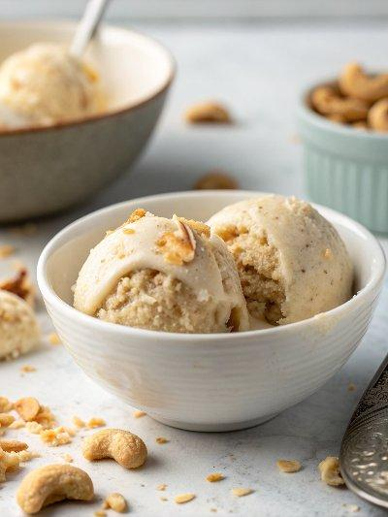

INGREDIENTS  - 1 1/4 cups raw cashews  - (2) 13.5 oz cans full fat coconut milk  - 3/4 cup granulated sugar  - 1/4 tsp salt  - 1 tbsp pure vanilla extract | PREP  COOK  1. Prepare: Place the bowl for your ice cream maker in the freezer a day before you plan on making it. I like to keep my bowl in the freezer when not in use, that way it's always ready!  2. Soak the cashews: Bring 3 cups (720ml) of water to a boil. Pour the hot water over the cashews and let soak for at least 5 minutes (or up to 3 hours).  3. Blend: Drain the cashews and discard the soaking water. Add them to a high powered blender along with the coconut milk, sugar, salt and vanilla extract. Blend on high speed until very smooth and creamy, a full 3-4 minutes. Don't blend for less time or you may end up with pieces of cashews.  4. Chill: Pour the mixture into a large bowl and place in the freezer to chill for about 30 minutes. It can get a bit warm when blending, and we want it to be cold when we churn it.  5. Churn: Set up your ice cream maker and remove both the ice cream maker bowl and the ice cream mixture from the freezer. Pour the mixture into the ice cream machine and churn according to the manufacturer instructions, about 20-25 minutes, until it looks like soft serve ice cream. If using any ad ins, add them in at the very end, once it looks like soft serve.  6. Freeze: Transfer the soft serve ice cream to a loaf pan and smooth the top with a spoon. Place a piece of plastic wrap directly on the ice cream to prevent ice crystals from forming. Place another layer of wrap on top of the pan and place in the freezer to set completely.  7. Serve: It should be ready in about 4-5 hours as firm ice cream. Remove the container from the freezer, let sit for a few minutes before scooping and serving. Enjoy with vegan hot fudge and whipped cream, if desired.  PLATING

