CREAMY GARLIC MUSHROOMS AND BACON  COOK TIME: 30 min  SOURCE:  #comfort-food #creamy #bacon | 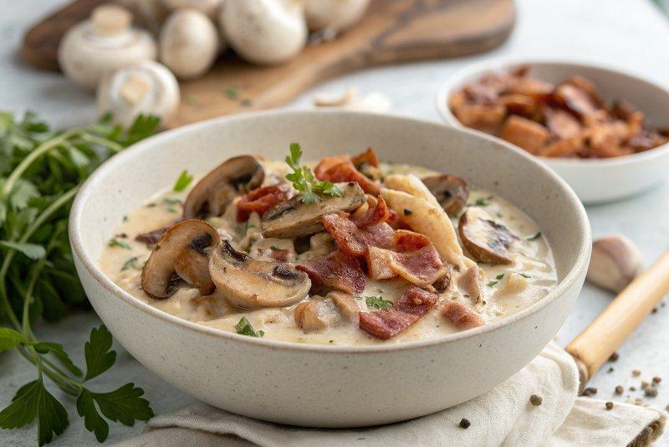

INGREDIENTS  - 8 oz bacon (cut into strips)  - 2 tbsp butter  - 26 oz brown mushrooms (washed, pat dry with paper towel)  - 1 tbsp olive oil  - 1/4 cup dry white wine (or chicken broth/stock)  - 6 cloves garlic (finely chopped)  - 1 1/2 cups heavy cream (thickened cream or evaporated milk)  - 1 tbsp fresh parsley (chopped)  - 1 tsp fresh thyme (chopped)  - 1 pinch salt (to season)  - 1 pinch pepper (to season)  - 1/2 cup fresh mozzarella (shredded or grated)  - 1/4 cup parmesan cheese (fresh shredded or grated ) | PREP  COOK  1. Fry the bacon in a large oven-safe skillet over medium heat until crispy. Use a slotted spoon to transfer to a paper towel lined plate to soak up some of the oil. Set aside.  2. In the same pan, melt the butter. Add the mushrooms, drizzle with oil and mix through, scraping up any browned bits from the bottom of the pan. Fry for 2-3 minutes to lightly brown mushrooms and release their juices (if any).  3. Pour in the wine (or broth) and let reduce for 2 minutes, while occasionally stirring. (Preheat broiler or oven grill.)  4. Add in the garlic and stir it through for a minute, until fragrant. Pour in the cream and herbs. Reduce heat down to low. Gently simmer until tender (about 4-5 minutes) and sauce is slightly thickened. Season with salt and pepper.  5. Add the bacon back in and give everything a good mix to combine all of the flavours together. Top the mushrooms with the mozzarella and parmesan cheese.  6. Broil until cheese is melted and bubbly and mushrooms are done to your liking (about 3-5 minutes).  7. Serve warm.  PLATING

