KEY LIME PIE  COOK TIME: 25 min  SOURCE:  #sweet #pie #citrus | 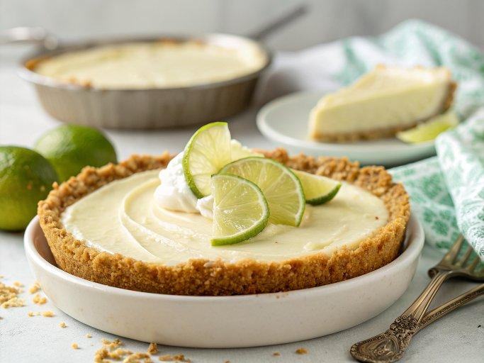

INGREDIENTS  - 9 full graham cracker sheets (136 g) (broken into halves)  - 2 1/2 Tbsp (32 g) granulated sugar  - 1/3 cup (76 g) unsalted butter, (melted)  - 3 large egg yolks  - 1 Tbsp lime zest or key lime zest  - 1 (14 oz) can sweetened condensed milk*  - 1/2 cup (120 ml) strained fresh lime juice or key lime juice  - 1/4 cup (56 g) full fat sour cream  - 3/4 cup (175 ml) heavy cream**  - 1 1/2 Tbsp (19 g) granulated sugar | PREP  COOK  1. Preheat oven to 350 degrees.  2. For the crust: In a food processor pulse graham crackers until they become fine crumbs. Pour into a mixing bowl, whisk in sugar then pour in butter and using a fork stir until evenly moistened.  3. Pour mixture into a 9-inch (23cm) pie plate and spread and press into an even layer along bottom and edges of pie dish, coming within about 1/3-inch (8cm) of the top edge.  4. Bake in preheated oven until golden brown, about 11 - 13 minutes. Remove from oven and allow to cool completely (meanwhile prepare filling). Reduce oven temperature to 325 degrees.  5. For the filling: In a mixing bowl whisk together egg yolks and lime zest. Stir in sweetened condensed milk, then mix in lime juice and sour cream until well blended.  6. Set mixture aside to rest about 15 minutes (this allows it time to thicken before pouring into the crust).  7. Pour into cooled crust and evenly spread. Bake in preheated oven until nearly set, 15 - 16 minutes (pie should jiggle just slightly).  8. Remove from oven and allow to cool on a wire rack 45 minutes, then chill in refrigerator 4 hours.  9. Pipe whipped topping over top, garnish with lime wedges if desired and cut into slices. Store pie in refrigerator.  1  0. For the whipped topping: in a mixing bowl (preferably one that has been chilled in freezer 5 minutes) using an electric hand mixer, whip heavy cream and sugar until stiff peaks form.  PLATING

